**STUDY OF STRUCTURAL, MICROSTRUCTURAL AND MECHANICAL PROPERTIES OF BOROSILICATE-BASED GLASS-CERAMIC COMPOSITES**

**A project report submitted**

**In partial fulfillment of the requirement for the award of the degree of**

**BACHELOR OF TECHNOLOGY IN**

**MECHANICAL ENGINEERING**

**By**

**M. SUJITH CHANDRA 19071A0333**

**P. SIDDARDTH 19071A0339**

**P.V.S SURAJ 19071A0341**

**V. SIMON PRASHANTH 19071A0358**

**Under the guidance of**

**Dr.CH. PRIYADARSINI**



**Department of Mechanical Engineering**

**VNR VIGNANA JYOTHI INSTITUTE OF ENGINEERING & TECHNOLOGY**

**(Autonomous)**

**Vignana Jyothi Nagar, Bachupally, Nizampet (SO), Hyderabad – 500 090 (Approved by AICTE & Govt. of T.S and Affiliated to JNTU, Hyderabad)**

**MAY, 2023.**







**VALLURUPALLI NAGESWARA RAO VIGNANA JYOTHI**

**INSTITUTE OF ENGINEERING AND TECHNOLOGY**

An Autonomous, ISO 9001:2015 & QS I-Gauge Diamond Rated Institute, Accredited by NAAC with ‘A++’ Grade

NBA Accreditation for B.Tech. CE,EEE,ME,ECE,CSE,EIE,IT,AME, M.Tech. STRE,PE,AMS,SWE Programmes

Approved by AICTE, New Delhi, Affiliated to JNTUH, NIRF(2022) 113 Rank in Engineering Category

College with Potential for Excellence by UGC,JNTUH-Recognized Research Centres:CE,EEE,ME,ECE,CSEVignana Jyothi Nagar, Pragathi Nagar, Nizampet (S.O.), Hyderabad – 500 090, TS, India.

Telephone No: 040-2304 2758/59/60, Fax: 040-23042761

E-mail: [postbox@vnrvjiet.ac.in](mailto:postbox@vnrvjiet.ac.in), Website: [www.vnrvjiet.ac.in](http://www.vnrvjiet.ac.in)

|  |  |  |
| --- | --- | --- |
|  |  |  |

**DEPARTMENT OF MECHANICAL ENGINEERING**

**CERTIFICATE**

This is to certify that the project report entitled **“STUDY OF STRUCTURAL, MICROSTRUCTURAL AND MECHANICAL PROPERTIES OF BOROSILICATE-BASED GLASS-CERAMIC COMPOSITES”** has been carried out at VNR VJIET, Hyderabad and submitted by the following Students.

S. No NAME OF THE STUDENT HALL TICKET No.

**1. M. SUJITH CHANDRA 19071A0333**

**2. PATHIPAKA SIDDARDTH 19071A0339**

**3. P.V.S. SURAJ 19071A0341**

**4. V.SIMON PRASHANTH 19071A0358**

In partial fulfillment of the requirements for the award of the Bachelor of Technology in Mechanical Engineering to Jawaharlal Nehru Technological University, Hyderabad at **VNR Vignana Jyothi Institute of Engineering & Technology** during the period of 2019-2023 is bonafide of the work carried out by them under the guidance and supervision of the undersigned. The results embodied in this project report have not been submitted to any other University or institution for the award of any Degree.

**Dr. CH. Priyadarsini Dr. B. SATYANARAYANA**

**Project Guide Head of the Department**

**Assistant Professor Mechanical Engineering**

**Mechanical Engineering VNR VJIET**

**VNR VJIET** 

**APPROVAL CERTIFICATE**

Viva-Voce examination conducted for the dissertation work entitled **“STUDY OF STRUCTURAL, MICROSTRUCTURAL AND MECHANICAL PROPERTIES OF BOROSILICATE-BASED GLASS-CERAMIC COMPOSITES”** is conducted on……………… and the work is approved for the award of **Degree of Bachelor of Technology in Mechanical Engineering.**

**INTERNAL EXAMINER EXTERNAL EXAMINER**

**DECLARATION**

We, the undersigned declare that the project report entitled **“STUDY OF STRUCTURAL, MICROSTRUCTURAL AND MECHANICAL PROPERTIES OF BOROSILICATE-BASED GLASS-CERAMIC COMPOSITES**” has been carried out and submitted in partial fulfillment of the requirements for the Award of the Bachelor of Technology in Mechanical Engineering at VNR Vignana Jyothi Institute of Engineering & Technology, affiliated to Jawaharlal Nehru Technological University, Hyderabad is an authentic work and has not been submitted to any other university.

**PLACE: HYDERABAD M.SUJITH (19071A0333)**

**DATE: P. SIDDARDTH (19071A0339)**

**P.V.S SURAJ (19071A0341)**

**V. SIMON PRASHANTH (19071A0358)**

**INDEX**

ACKNOWLEDGEMENT……………………………………. I

ABSTRACT………………………………………………….. II

TABLE OF CONTENTS…………………………………… III

LIST OF FIGUREURES………………………………………IV

# 

# ACKNOWLEDGEMENT

The satisfaction and euphoria that accompany the successful completion of any task would be incomplete without mentioning the people who have made it possible because success is the epitome of hard work. So, with gratitude, we acknowledge all those whose guidance and encouragement have made our efforts successful.

We express our deep gratitude to our Principal **Dr. C.D. NAIDU** and the Head of the Department of Mechanical Engineering **Dr. B. SATYANARAYANA** for their encouragement, which went a long way in the successful completion of this project.

We express our gratitude to our guide **Dr. Ch. Priyadarsini**, for her valuable suggestions, constant encouragement, and support of our Endeavour.

We also express our gratitude to **Dr**. **C. Thirmal,** Assistant Professor, H&S Department for his constant guidance, ideation, and encouragement of this project.

We also take this opportunity to express our gratitude to all the faculty of the Mechanical Department from whom we received technical guidance.

We would like to thank the **Center for Nano Science and Technology, VNR VJIET** for supporting us by permitting us to use the equipment for our project.

Our cordial regards to our major project coordinator **Mr. NAVEEN REDDY CH,** Assistant Professor for his encouragement and moral support.

Finally, we thank our parents and friends who directly or indirectly influenced us to propel the project to its completion.

# ABSTRACT

This project report is a detailed analysis of the possibilities and advantages of replacing Borosilicate Glass with a Borosilicate-Alumina (Al2O3) Composite. The use of glass vials in the pharmaceutical and food packaging industries has been a long-standing standard; however, concerns regarding breakage and contamination have led to the exploration of alternative materials and thus raises the question of using better composite materials for the use of the above-mentioned purposes. The changes in the mechanical properties are observed in the variation in the Al2O3 and Cu2O content varying at 10%, 20%, and 30% of wt%. By way of compaction and sintering of the powdered materials at 850°, pellets have been fabricated to achieve grain growth of the materials and to prepare the pellets such that they can be tested for various properties. The pellets are studied for their structure with an Optical Microscope at 200x magnification where it was found that the pellets were non-porous and free of any surface defects, the fiber orientation of the composite material shows that the stiffness of the material has increased. The pellets are studied for their microstructure by performing SEM analysis where it was found that the glass formed a featureless surface with no distinct grains or crystals whereas the Alumina (Al2O3) is observed to have formed tiny chip-like structures and Copper Oxide (Cu2O) is observed to form spheres that are observed to be nanoparticles. The pellets are finally tested for the hardness of the composite pellets by the Micro Vickers Hardness method, where the results show a substantial increase in the hardness values by about 150HV for 90% Borosilicate and 10% Alumina (Al2O3) as compared to 100% Borosilicate and the next highest value is achieved by the mixture of the 3 components i.e., 80% Borosilicate + 10% Alumina + 10% Copper Oxide at 47HV higher than the Base sample. We can observe that the slight addition of Alumina increases the hardness substantially but further addition reduces the hardness. We also observe that the addition of Copper Oxide increases the hardness of the composite. The reported changes thus show a better result than a pure Borosilicate composite at a minimal cost difference, making it viable for commercial production of the proposed composite glass and solving the problem of breakage and contamination.

**TABLE OF CONTENTS**

ACKNOWLEDGEMENT 1

ABSTRACT 2

CHAPTER 1 7

INTRODUCTION 7

1.1 Introduction to Composite Materials: 7

1.2 History of Different Glass Vial Materials: 8

1.3 Introduction to Borosilicate Glass: 9

CHAPTER 2 10

LITERATURE REVIEW 10

CHAPTER 3 16

WORK METHODOLOGY 16

CHAPTER 4 18

SELECTION OF MATERIAL 18

4.1 Borosilicate : 19

4.2 Development of a New Borosilicate Composite: 19

4.3 Comparison of Possible Reinforcements: 20

4.4 Justification of Alumina: 23

CHAPTER 5 24

PREPARATION OF COMPOSITE 25

5.1 Scaling And Mixing 25

5.1.1 Scaling 25

5.1.2 Mixing: 29

5.2 Grinding: 30

5.2.2 Grinding: 30

5.3 Pellet Preparation: 31

5.4  Sintering: 40

CHAPTER 6 43

RESULTS AND DISCUSSIONS 43

6.1 Micro Vickers Hardness: 43

6.2 Structural analysis Through Optical Microscope: 45

6.3 Microstructural analysis Through Scanning Electron Microscopy: 49

CHAPTER 7 52

7.1 Conclusions: 52

7.2 Future Scope: 52

CHAPTER 8 53

REFERENCES 53

**LIST OF FIGURES**

Figure 1.1 : Composite Materials 7

Figure 1.2: Pie Chart of Borosilicate Glass Composition 9

Figure 5.1 : Borosilicate(Base) Scaling………………………………………………………… 25 Figure 5.2: Borosilicate(Base) Mixture 25

Figure 5.3: Borosilicate(90%)+Alumina(10%) Scaling………………………………………... 26 Figure 5.4: Borosilicate(90%)+Alumina(10%) Mixture 26

Figure 5.5 : Borosilicate(80%)+Alumina(20%) Scaling……………………………………….. 26 Figure 5.6 : Borosilicate(80%)+Alumina(20%) Mixture………………………………………. 26

Figure 5.7: Borosilicate(70%)+Alumina(30%) Scaling………………………………………... 26 Figure 5.8: Borosilicate(70%)+Alumina(30%) Mixing………………………………………. 26 Figure 5.9: Borosilicate(90%)+Copper oxide(10%) Scaling…………………………………... 26 Figure 5.10: Borosilicate(90%)+Copper oxide(10%) Mixing…………………………………….26

Figure 5.11 : Borosilicate(80%)+Copper oxide(20%) Scaling…………………………………. 27 Figure 5.12: Borosilicate(80%)+Copper oxide(20%) Mixing…………………………………. 27 Figure 5.13 : Borosilicate(70%)+Copper oxide(30%) Scaling……………………………………28 Figure 5.14 : Borosilicate(70%)+Copperoxide(30%) Mixture……………………………………28 Figure 5.15: Polyvinyl alcohol Solution…………………………………………………………..30 Figure 5.16 : PVA Solution preparation 30

Figure 5.17: Die sleeve and bottom die 31

Figure 5.18: Combined Bottom die and Die sleeve 31

Figure 5.19: Die core and die sleeve 32

Figure 5.20: Die core is locked in the die sleeve 32

Figure 5.21: Composite Material is added 33

Figure 5.22: Pushing Rod is Connected to die sleeve 33

Figure 5.23: Die sleeve is locked under Hydraulic Press 34

Figure 5.24: 50 Kgf Pressure is maintained……………………………………………………. 34 Figure 5.25 : Hand bar setup 34

Figure 5.26 : Mold remover and die sleeve 35

Figure 5.27: Mold remover is put under die sleeve 35

Figure 5.28: Pellet is separated from die sleeve 36

Figure 5.29: Pellet is separated from die sleeve 36

Figure 5.30 : Above are pellet pictures of all 24 samples neatly labeled and locked 39

Figure 5.31: Pellets are placed inside the Oven 40

Figure 5.32: Initial Temperature of Furnace 41

Figure 5.33: Furnace at 300° C 41

Figure 5.34 : Furnace at 850° C 42

Figure 6.1: Bar graph on Hardness test results 44

Figure 6.2: Borosilicate(100%) 45

Figure 6.3: Borosilicate (90%)+ Alumina(10%) 45

Figure 6.4: Borosilicate(80%)+ Alumina(20%) 46

Figure 6.5: Borosilicate(70%)+ Alumina(30%) 46

Figure 6.6: Borosilicate(90%)+ Copper oxide(10%) 47

Figure 6.7: Borosilicate(80%)+ Copper oxide(20%) 47

Figure 6.8: Borosilicate(70%)+ Copper oxide(30%) 48

Figure 6.9: Borosilicate(80%)+Alumina(10%)+ Copper oxide(10%) 48

Figure 6.10: SEM image of Borosilicate (100%) 49

Figure 6.12: SEM image of Borosilicate (80%) + Copper oxide(20%) 50

Figure 6.13: SEM image of Borosilicate(80%) +Alumina(10%)+ Copper oxide(10%) 51

**LIST OF TABLES**

Table 1**:** Comparison of properties of possible Borosilicate reinforcements. 22

Table 2 **:** Comparison of Predicted combined properties. 23

Table 3: Micro Vickers Hardness Test results 43

# CHAPTER 1

# INTRODUCTION

# 1.1 Introduction to Composite Materials:

Composite materials are a type of engineered material created by combining two or more distinct components with differing qualities to create a new material with improved properties. In order to create a composite material with better mechanical, thermal, electrical, and other qualities, the component elements, also known as constituent materials, are merged while maintaining their distinct features. In a number of industries, including aerospace, automotive, construction, sports equipment, and biomedical engineering, composite materials have been thoroughly explored and produced.

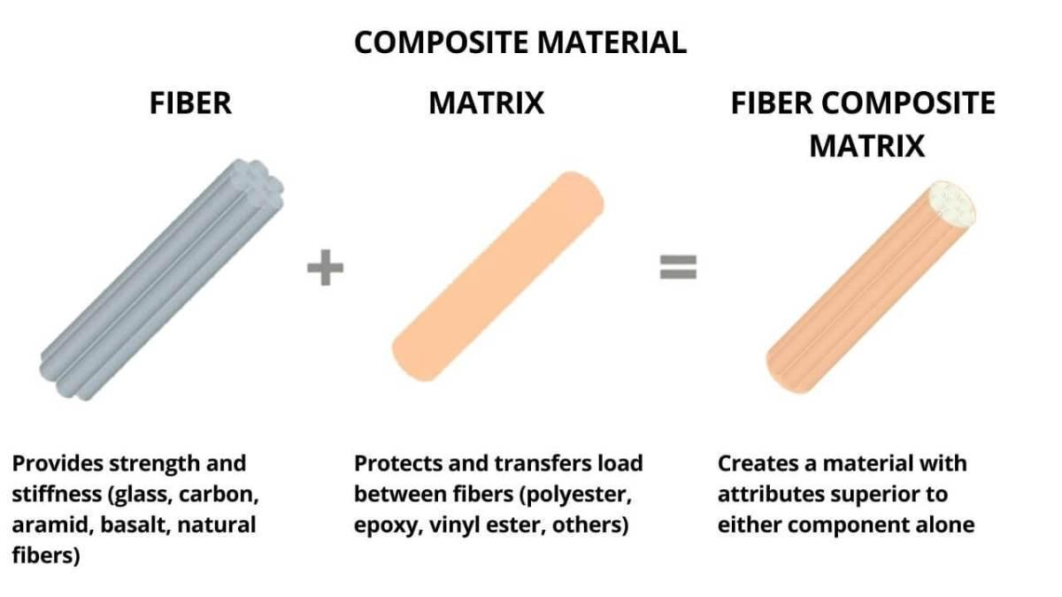

Figure 1.1: Composite Materials

*Source: https://i0.wp.com/midwestcomposites.com.my/wp-content/uploads/2022/01/What-is-Composite-materials.jpg?resize=1200%2C675&ssl=1*

Composite materials are widely used because of the special combination of qualities that make them the perfect solution for many technical issues. For instance, composite materials may be made to be both strong and light, which makes them perfect for use in aerospace applications. Moreover, they may be made to have a high resistance to corrosion and wear, which qualifies them for use in tough conditions. Composite materials are also valuable in a variety of applications because they may be designed to have a certain thermal conductivity, electrical conductivity, or other qualities.

# 1.2 History of Different Glass Vial Materials :

Glass vials have been used for years to store and transport various liquids and solids. Glass vials have been made from a variety of materials over the years, each with its own advantages and disadvantages.

1. Soda-Lime Glass: The first glass vials were constructed using soda-lime glass, which is a form of glass created by mixing soda ash, limestone, and silica sand. Because soda-lime glass is cheap, simple to make, and chemically resistant, it is still often used today. It can, however, interact with some substances and deteriorate with time, making it unsuitable for particular uses.
2. Borosilicate Glass: In the late 19th century, borosilicate glass was created. This kind of glass is formed by mixing soda ash, limestone, and silica sand with boron oxide. Borosilicate glass is the best material to use in situations where temperature fluctuations are frequent because it is significantly more resistant to thermal shock and has a lower coefficient of thermal expansion. It may be used with a larger variety of chemicals since it is more resistant to chemical assault than soda-lime glass.
3. Fused Silica: Made by melting silica at very high temperatures, fused silica is a highly pure kind of glass. Because of its great purity, superior chemical resistance, and thermal stability, fused silica is the best material to utilise in applications where high-purity or high-temperature conditions are required.
4. Amber Glass: To give it its unique amber hue, amber glass is a form of glass that has been tinted using iron and sulphur compounds. Since it filters ultraviolet and blue light, which over time can cause some molecules to deteriorate, it is frequently used to preserve substances that are sensitive to light. Soda-lime or borosilicate glass is commonly used to create amber glass.
5. Quartz Glass: Quartz glass is a form of glass that is entirely composed of silica. It is perfect for use in high-temperature applications, such as in laboratory ovens and furnaces, because to its extraordinarily high purity and thermal durability.

# 1.3 Introduction to Borosilicate Glass:

Borosilicate glass is a form of glass that is mostly made of boron trioxide and silica. The exceptional resilience of this kind of glass to mechanical impact, chemical corrosion, and thermal stress is well recognised.

Borosilicate glass is frequently used for home items like cookware and drinkware as well as in scientific and laboratory settings. It is frequently used for products like baking pans, beakers, test tubes, and coffee carafes that must tolerate high temperatures and rapid temperature fluctuations.

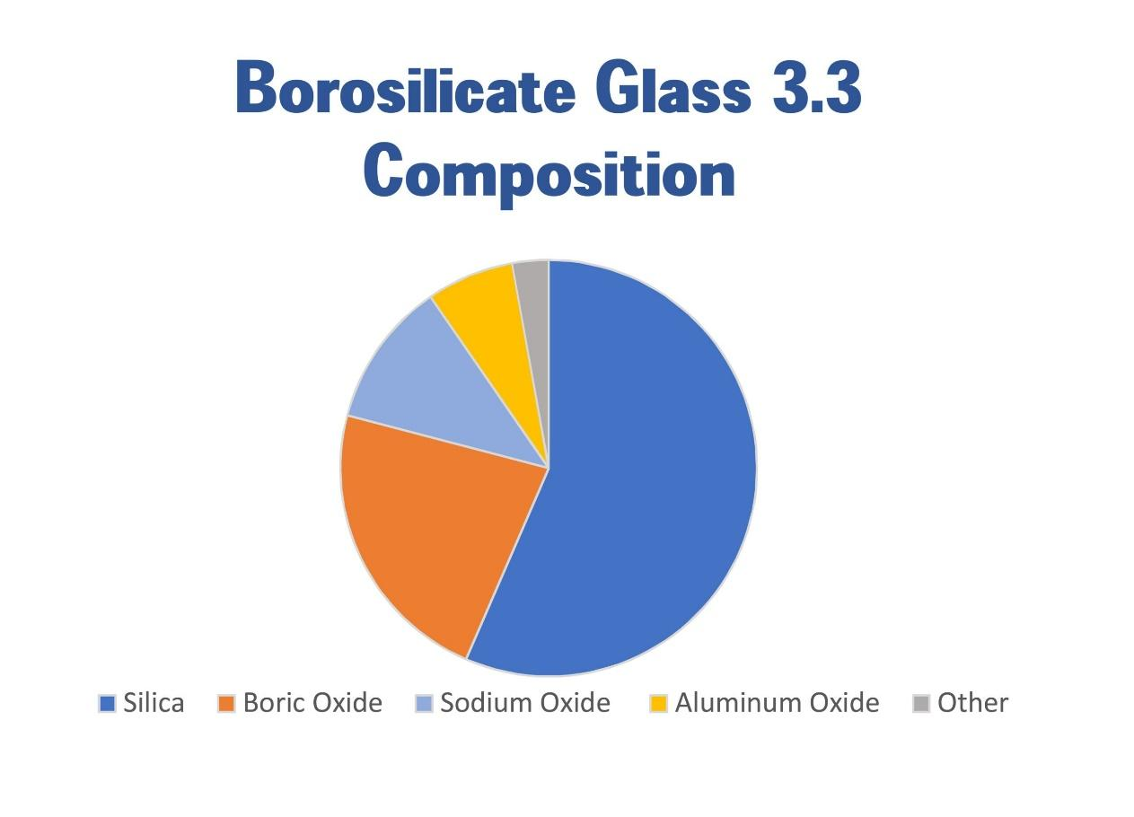

Figure 1.2: Pie Chart of Borosilicate Glass Composition

*Source: https://www.ablazeexport.com/wp-content/uploads/2020/12/Borosilicate-Glass-3.3-Composition-scaled.jpg*

Due to its low coefficient of thermal expansion, which allows it to expand and compress without breaking or shattering, borosilicate glass has special qualities. Moreover, borosilicate glass may be used in industrial and laboratory settings because it is resistant to chemical corrosion caused by acids, bases, and other substances. Borosilicate glass is a strong and dependable substance that is ideal for a wide range of applications, particularly those requiring strong resistance to thermal and chemical stress.

# CHAPTER 2

# LITERATURE REVIEW

**Dakuri Ramakanth et al.** [1]This research reviews unique hybrid packaging materials, cyclic olefins polymers with nanolayer glass, and vaccine vials for the distribution and storage of COVID-19 vaccines. With an emphasis on bar codes, rapid response codes, vaccine vial monitors, anticounterfeiting, and traceability measures, they concentrated on vaccine packaging, auto-disable syringes, stoppers, and closures, as well as a chronology of the packaging system and the labeling of the vaccine packages.

**Benjamin Mos et al.** [2]This study compares the effects of preservation and storage methods on the total alkalinity (AT) of seawater, estuarine water, freshwater, and groundwater samples stored for 0–6 months. It also discusses how alkalinity of various water samples can be affected by mercury preservation and borosilicate vial storage..

**Nurul Hanim Shamsudin et al.** [3]This study shows how to make vertically well-aligned zinc oxide (ZnO) nanowires on amorphous borosilicate glass (BSG) using a simple chemical vapor deposition (CVD) procedure using a vapor trapping strategy. In order to controllably grow ZnO NWs on any much less expensive amorphous substrates for the creation of low-cost energy converter heat cell devices based on ZnO nanowires, this vapor trapping technique employing BSG substrates offered a promising alternative.

**Robert A. Schaut et al.** [4] This study is about a historical review of glasses used for parenteral packaging. It talks about how glass has special qualities that make it the best material for such a crucial role, including hermeticity, transparency, strength, and chemical durability. It also talks about how improvements have raised the standard of glass containers and enhanced their capacity to keep their contents safe. Additionally, it takes advantage of issues like delamination, cracks, and glass particles.

**A. Wereszczak et al.** [5]This paper examines the strength and contact damage responses of soda-lime-silicate and borosilicate glass. This essay provides information on the mechanical, chemical, and other characteristics of borosilicate and soda-lime glass that are being studied.

**Poussy Aly et al.** [6]In this study, various transparent amorphous borosilicate glass systems with varying percentages of PbO, BaO, and SrO metal oxides were evaluated as gamma-ray shielding materials. In order to compare the results for some glass matrices used in industry, including RD-30 and LX-57B, the half-value layer and density for the prepared samples were analyzed. The goal was to ascertain how well the glass matrices protected against the gamma radiations discussed.

**Dominique Ditter et al.** [7]This paper discusses the Effects of Vial Washing and Depyrogenation on Surface Properties and the Delamination Risk of Glass Vials. This study examined the effects of vial washing and depyrogenation on the surface characteristics of glass vials for a predetermined set of vials, as well as the evaluation of various residual water volumes. And finally, the vial processing conditions must be evaluated in order to reduce the risk of glass delamination during parenteral product storage.

[**Sebastian Bruns**](https://www.frontiersin.org/people/u/400519) **et al.** [8]The addition of Al2O3 caused structural changes in the borosilicate glass, including the formation of new bonds and changes in the coordination of the network-forming cations. The mechanical characteristics of the glass were enhanced as a result of these modifications, including an increase in hardness, fracture toughness, and compressive strength.The research also revealed that between 5-7 mol% of Al2O3 was the ideal amount to add to borosilicate glass, as higher amounts decreased the glass transition temperature and reduced the mechanical properties.

[**Robert**](https://ceramics.onlinelibrary.wiley.com/authored-by/ContribAuthorRaw/EAGAN/ROBERT+J.)**.J et al.** [9]The results of the aluminosilicates that were studied in terms of Al3+:Na+ ratios. At an Al3+:Na+ ratio of 1, the mechanical properties do not exhibit maxima or minima. Increased coherency of the glass network is consistent with higher moduli and toughness as the Al3+:Na+ ratio rises. B2O3-containing glasses have slightly higher moduli but are much tougher than Al2O3-containing ones. While the fracture toughnesses are comparable, the moduli of calcium aluminosilicate glasses are about 25% higher than those of sodium aluminosilicates.

**Henrik Bradtmüller et al.** [10]The substitution of B2O3 for Al2O3 and Na2O for MgO reduces N4, the fraction of four-coordinate boron, while increasing Crack Resistance.

[**Kacper Januchta**](https://ceramics.onlinelibrary.wiley.com/authored-by/ContribAuthorRaw/Januchta/Kacper) **et al.** [11]Due to its high level of cross-linking, the sodium borosilicate glass with equal amounts of soda and boria displays the highest elastic moduli and hardness. Compared to the other glasses examined in this study, the metaluminous aluminoborate glass has the lowest elastic moduli and hardness, which is consistent with its relatively flexible network. When the glass network topology is taken into account, existing semi-empirical models can satisfactorily predict both Young's modulus and Vickers hardness.

**Aldo R. Boccaccini** et al. [12] Calcination and addition of Alumina rich residue improved the properties compared to pure BSG glass with the best balance between strength, density and crystalline volume. Though the formation of cristobalite was not possible with sintering, the valoxy evolved gases that were entrapped and formed closed pores, and with the increase in temperature, the pores grew in size, leading to reduction in strength.

**M.M.R.A. Lima et al.** [13]In sintered borosilicate glass, cristobalite (SiO2) was found according to XRD patterns, and the presence of Al2O3 prevents the formation of cristobalite. This behavior is brought on by some Al3+ ions diffusing from alumina to glass, which changes the composition and structure of the glass, as shown by SEM/EDS. In composites with 10% Al2O3 that achieved the lowest thermal expansion coefficient value (4.6 106 °C), cristobalite was undetected. The amount of Al3+ ions present in the glass structure as modifiers and formers led to an increase in conductivity (dc and ac). With the addition of Al2O3, dielectric constant values in the range of 5.0–7.2 increased, and values of loss tan (1.5–2.1 102) show that these materials are effective insulators.

**Yu Paulıukevıch et al.** [14] The borosilicate glass's viscosity and melting temperature both decreased as a result of the addition of raw materials containing aluminum. According to the study, 3-5 wt% of raw materials containing aluminum are best to add to borosilicate glass composition because higher amounts reduced the material's ability to form fibers and mechanical properties.

**Arun Krishnamurthy et al.** [15]The addition of aluminum or gallium to borosilicate glasses caused changes in their network structure, including an increase in polymerization and the formation of new types of bonds. Due to these modifications, the glasses had a greater propensity to crystallize into nepheline, a common mineral in volcanic rocks. The study also discovered that network formation and crystallization behavior were affected by the type and quantity of cations added to the glass. Aluminum was found to be less effective than gallium at encouraging network formation and inhibiting nepheline. These discoveries affect how borosilicate glasses are created and processed for a variety of uses, including in the study of geology where nepheline-rich rocks are frequently found.

**Amanpreet Saini et al.** [16]Aluminum oxide was found to change the glass transition temperature and reduce density in lead borate glasses. Aluminum oxide was added to borosilicate glasses, which resulted in changes to the glass transition temperature, the refractive index, and density. These discoveries have effects on how glasses are created and processed for use in a variety of applications, such as optics and electronics, where the performance of glasses depends on their physical characteristics.

**A.P.Raut et al.** [17]The alumina was discovered to act as a network modifier, resulting in a decrease in the glass transition temperature, an increase in density, and a shift in the Raman spectra towards lower wavenumbers. The research discovered that gamma irradiation had an impact on the glass properties, causing changes in the Raman spectra as well as changes in density and glass transition temperature. The outcomes also demonstrated a relationship between gamma irradiation and changes in the refractive index and microhardness of the glasses. The results have implications for how glasses are designed and processed for use in a variety of applications, including the immobilization of nuclear waste, where the characteristics of glasses play a crucial role in performance.

**K.P. Kumar et al.** [18]According to the study, the addition of alumina led to an increase in the melting temperature of the composites as well as a decrease in the thermal expansion coefficient of the materials. The strength and ductility of the composites decreased at higher temperatures, with the degree of the decrease depending on the amount of alumina in the composite. The study's conclusions have implications for the use of these composite materials in high-temperature applications where the performance of glasses is essential.

**R.T. Coyle et al.** [19]The study's findings demonstrated that the low coefficient of thermal expansion of the alumina-borosilicate sheet glass made it resistant to thermal shock. The glass also demonstrated strong weathering resistance, demonstrating its ability to withstand exposure to environmental elements like sunlight, moisture, and temperature changes without degrading. The study also discovered that the glass had excellent mechanical properties, including high flexural strength and fracture toughness.

[**A. A. El-Kheshen**](javascript:;)**et al.** [20]X-ray diffraction (XRD) and scanning electron microscopy (SEM) were used to examine the microstructure of composites that contained varying amounts of nano-alumina and titania. The findings demonstrated that adding nano-alumina and titania improved the composites' density and hardness while lowering their fracture toughness.The nano-alumina and titania particles were well-dispersed in the borosilicate matrix and did not form any new phases, according to the SEM and XRD analyses.

[**Guo-hua Chen**](javascript:;) **et al.** [21]The findings demonstrated that the composites could be successfully sintered at low temperatures and that adding ceramic powders improved the mechanical and thermal properties of the composites. The borosilicate glass matrix's homogeneous distribution of the ceramic powders was revealed by the microstructure analysis.

**M.F Zawrah et al.** [22]The microstructure analysis showed that the cristobalite phase was dispersed throughout the composite, which caused pores and cracks to form and lower the composites' mechanical strength and thermal stability.

**Duygu şen baykal et al.** [23]The results showed that BSG-Al2O3 composites exhibited the highest LAC compared to BSG and BSG-Bi2O3. The addition of alumina in BSG increased its Linear Attenuation Coefficient values. LAC values also increased with an increase in the thickness of the glass samples.

**Loïc Perrière et al.** [24] By combining aluminum and metallic glass (Zr57Cu20Al10Ni8Ti5) powders with similar particle sizes using spark plasma sintering (SPS), composites with volume fractions ranging from 10 to 90 percent were created.The strength initially varies monotonously but nonlinearly.Second, from low to high Al content, stress-strain curves successively display absence of plasticity, plasticity with a sharp decline in strength associated with local damage, and finally plasticity with work hardening.

**G. Banu Prakash et al.** [25] The gain in fracture toughness at room temperature is considerably smaller than the value expected from the dispersion of metallic particles in a brittle matrix. Microcracking at the interfaces appears to be responsible for the poor toughness. The apparent viscosity of composites at a given temperature was not influenced by the dispersed phase content. Trends in the variations of flow stress and viscosity of composites can be attributed to the soft and ductile nature of dispersed Cu in the glass matrix.

**Bo Li et al.** [26]The addition of smaller particle size Al2O3 can also increase the flexural strength and fracture toughness of the composites, improving their sinterability and densification, reducing their porosity, and improving their mechanical properties.

**Minghui Chen et al.** [27]findings demonstrated that the thermal stability and hardness of the composite coatings were enhanced by the addition of alumina nanoparticles to the glass matrix.

**William D. Wolf et al.** [28]The mechanical characteristics of the composites, such as hardness, flexural strength, and fracture toughness, were significantly enhanced by the addition of alumina particles. However, it was discovered that the addition of alumina also made the composites more brittle and less transparent.

**Byeong Hoon Bae et al.** [29]The findings demonstrated that the L-PBF procedure can be used to create glass/alumina composites, and that the mechanical characteristics of the composites can be regulated by varying the powder composition and laser power. In comparison to pure glass and pure alumina samples, the composites showed greater strength and stiffness.

# CHAPTER 3

# WORK METHODOLOGY

**Select the matrix material**: Choosing an appropriate matrix material is the first stage in creating a composite material. The component that binds the reinforcement material and gives the composite its shape and strength is known as the matrix material.

**Literature research on Reinforcement material**: The next stage is to choose the optimum reinforcement material for the desired attributes of the composite. In this study, several reinforcing materials' mechanical characteristics, costs, availability, and compatibility with the selected matrix material will be assessed.

**Select the reinforcement material**: The best reinforcing material for the composite is chosen based on the literature review. The addition of the reinforcement material, usually a fiber or particle, improves the composite's strength, stiffness, and other mechanical qualities.

**Determine the volume fraction**: The ideal amount of reinforcement material to mix with the matrix material is estimated using the volume fraction of the reinforcement material. The volume fraction is a measurement of how much of the composite's volume is taken up by the reinforcement like 10% w/w.

**Prepare the composite material**: The matrix and reinforcement components are combined to create the composite material after being chosen. This is often accomplished by combining the ingredients through a process of grinding to achieve a uniform distribution of the reinforcement material throughout the matrix material.

**Hydraulic press for manufacturing pellets**: After pressing the composite material into pellets, a hydraulic press is used. The size and shape of the pellets, which are commonly cylindrical or rectangular.

**Sintering the pellets in a muffle furnace**: The pellets are then sintered at a high temperature in a muffle furnace to fuse the matrix and reinforcing components together. By heating the mixture to 8500 C Grain growth of the matrix and reinforcement will start and the combined properties will be more.

**Testing the pellet composites**: It is the last stage in determining whether they have the appropriate mechanical properties. To measure the strength of the pellets, mechanical tests like Micro Vickers are done and for the microstructural analysis, SEM test is done. The suitability of the composite for the intended application is next assessed using the test findings.

From the given Work methodology following Flowchart is drawn

## CHAPTER – 04

## SELECTION OF MATERIAL

### **4.1 Borosilicate :**

Borosilicate glass is a type of glass that is composed primarily of boron and silica. Due to its low thermal expansion and high thermal shock resistance, it is a preferred material for products like lighting, cookware, and laboratory glassware. When borosilicate glass is combined with other substances, such as metals or ceramics, a composite substance with special properties can result.

The specific materials used and the way they are combined can have a significant impact on the properties and applications of borosilicate composites. Some of the potential properties and advantages of borosilicate composites include:

* High strength and durability
* Thermal and chemical resistance
* Optical transparency
* Customizability
* Cost-effectiveness
* Sustainability

Compared to conventional materials, borosilicate composites have a number of benefits, including:

**High strength:** Borosilicate composites are ideal for a variety of applications because of their great mechanical strength.

**Low thermal expansion:** Composites made of borosilicate are resistant to thermal shock and stress because of their low thermal expansion coefficient.

**Chemical resistance:** Composites made of borosilicate are extremely resistant to chemical attack, making them perfect for usage in situations with severe chemicals.

**Compatibility:** Borosilicate composites are biocompatible, making them suitable for usage in a variety of medical settings and in close proximity to living tissue.

**Electrical insulation:** Excellent electrical insulation characteristics of borosilicate composites make them valuable in electrical and electronic applications.

### **4.2 Development of a New Borosilicate Composite:**

Due to its exceptional thermal and chemical resistance, borosilicate glass is a widely used material. However, due to its poor mechanical characteristics, it can only be used in some applications. This restriction can be removed by combining borosilicate with other substances to create composites that have better mechanical qualities. In order to create a new composite with better properties, we will investigate potential materials to combine with borosilicate.

New borosilicate composites are required for a number of factors, including:

**1. Performance improvement**: New borosilicate composites can outperform conventional materials in terms of performance. For instance, they might be more suitable for new or demanding applications due to their higher strength, greater toughness, or improved thermal stability.

**2.Customization:** Brand-new borosilicate composites can be created to satisfy the demands of a specific application. The properties of the composite can be modified to make them more suitable for particular use cases, such as aerospace, automotive, or medical applications.

**3.Sustainability:** There is an increasing demand for more environmentally friendly, sustainable materials. The carbon footprint of new borosilicate composites can be decreased by using more environmentally friendly and environmentally sound manufacturing techniques and materials.

**4.Cost-effectiveness:** By making new borosilicate composites more affordable than conventional ones, a wider range of industries and applications can benefit from their use.

**5. Innovation**: in materials science and engineering may be sparked by the creation of novel borosilicate composites. This can result in fresh uses and discoveries that weren't feasible before with conventional materials.

### **4.3 Comparison of Possible Reinforcements:**

**Alumina:**

Alumina is a popular material in composites due to its high strength, stiffness, and hardness. It can enhance the mechanical qualities of the composite, such as its compressive strength, wear resistance, and fracture toughness, when added to borosilicate. Alumina can also improve the composite's thermal conductivity and thermal shock resistance.

**Zirconia:**

Zirconia is a ceramic substance renowned for its extreme toughness, wear resistance, and strength. It can enhance the mechanical qualities of the composite, such as its strength and toughness, when added to borosilicate. The composite's thermal conductivity and thermal shock resistance can both be improved by the addition of zirconia.

**Carbon Nanotubes**

Because of their high strength and stiffness, carbon nanotubes (CNTs) are a desirable material to incorporate into borosilicate composites. CNTs can improve the composite's strength and stiffness when combined with borosilicate. The electrical and thermal conductivity of the composite can both be enhanced by the addition of CNTs.

**Silicon Carbide**

A ceramic material with high strength, hardness, and wear resistance is silicon carbide (SiC). It can enhance the mechanical qualities of the composite, such as its strength, toughness, and wear resistance, when added to borosilicate. The composite's thermal conductivity and thermal shock resistance can both be improved with the addition of SiC.

**Titanium Dioxide**

Titanium dioxide (TiO2) is a ceramic material known for its high strength and stiffness. It can enhance the mechanical qualities of the composite, such as its strength and stiffness, when added to borosilicate. The composite's thermal conductivity and thermal shock resistance can both be improved with the addition of TiO2. Additionally, TiO2 can give the composite some advantageous traits like UV resistance and self-cleaning capacity.

The mechanical and thermal properties of the composite can be enhanced by mixing borosilicate with alumina, zirconia, carbon nanotubes, silicon carbide, and titanium dioxide. The material to be added will depend on the desired qualities of the composite and the intended use. The strength, toughness, wear resistance, and thermal shock resistance of the composite can be greatly improved by the addition of these materials, making it appropriate for a variety of applications. To improve the composite's composition and look into possible applications, more study and testing is needed.

Here is a table comparing the properties of five possible reinforcements for borosilicate composites: alumina, zirconia, carbon nanotubes (CNTs), silicon carbide (SiC), and titanium dioxide (TiO2).

Table 1**:** Comparison of properties of possible Borosilicate reinforcements.

|  |  |  |  |  |  |
| --- | --- | --- | --- | --- | --- |
| **Material** | **Strength**  **(MPa)** | **Elastic Modulus**  **(GPa)** | **Fracture**  **Toughness**  **(MPa/m^(1/2))** | **Thermal**  **Conductivity**  **(W/mK)** | **Thermal**  **Expansion**  **Coefficient**  **(10^-6/K)** |
| Alumina | 350-500 | 350-450 | 3-4 | 20-35 | 7-8 |
| Zirconia | 800-900 | 200-210 | 4-5 | 2-4 | 10-11 |
| CNTs | 20-100 | 1.0-1.2 | 2-3 | 3000-6000 | 1-2 |
| SiC | 400-600 | 400-500 | 3-4 | 120-150 | 3-4 |
| TiO2 | 150-250 | 200-240 | 2-3 | 5-10 | 8-9 |
| CuO | 70-100 | 130-180 | 0.7-1.1 | 10-15 | 8.9-9.6 |

***Source:*** *"Properties and Applications of High-Performance Ceramics" edited by Dong liang Jiang and Hua-Tay Lin*

Here are some discussions about the possible reinforcements as shown in the table above:

**Strength:** Alumina and SiC have the highest strength, followed by zirconia and TiO2, while CNTs have the lowest strength.

**Elastic Modulus:** Alumina has the highest elastic modulus, followed by SiC and zirconia, while CNTs and TiO2 have the lowest elastic moduli.

**Fracture Toughness:** Zirconia has the highest fracture toughness, followed by alumina and SiC, while CNTs and TiO2 have the lowest fracture toughness.

**Thermal Conductivity:** CNTs have the highest thermal conductivity, followed by SiC and alumina, while zirconia and TiO2 have the lowest thermal conductivities.

**Thermal Expansion Coefficient:** CNTs have the lowest thermal expansion coefficient, followed by zirconia and SiC, while alumina and TiO2 have the highest thermal expansion coefficients.

The type of reinforcement to utilize in borosilicate composites relies on the desired qualities of the material and the intended use. Alumina and SiC are good options for applications requiring high strength and stiffness, zirconia is a good choice for those requiring high fracture toughness, CNTs are a good option for those requiring high thermal conductivity and low thermal expansion coefficient, and TiO2 can be used for those requiring a lower strength composite with UV resistance and self-cleaning capability.

### **4.4 Justification of Alumina:**

Alumina is a preferred reinforcement material for borosilicate composites due to its high hardness and wear resistance. The improved mechanical characteristics of the resulting composite material, which is made of borosilicate and alumina, include higher hardness, strength, and stiffness.

Alumina's exceptional hardness is one of the primary factors making it a great reinforcement material for borosilicate. The Mohs scale gives alumina a hardness grade of 9, which is much higher than the borosilicate's rating of 7.5. Alumina particles operate as hard inclusions that raise the composite's overall hardness when they are mixed with borosilicate.

Alumina, in addition to its great hardness, has a small particle size, which allows it to diffuse evenly throughout the borosilicate matrix. The reinforcing particles are evenly distributed throughout the composite material, guaranteeing uniform characteristics throughout.

Additionally, because of its superior wear resistance, alumina is especially beneficial in applications where the composite material is subjected to high levels of abrasion. The wear resistance of the composite can be greatly increased by adding alumina particles to borosilicate, making it suitable for use in a range of engineering and industrial applications.

The below table shows the Predicted Combined Properties when Possible Reinforcements are Mixed with Borosilicate

Table 2 **:** Comparison of Predicted combined properties.

|  |  |  |  |  |  |
| --- | --- | --- | --- | --- | --- |
| **Composite**  **+**  **Reinforcement** | **Strength**  **(MPa)** | **Elastic**  **Modulus**  **(GPa)** | **Fracture**  **Toughness**  **(MPa/m^(1/2))** | **Thermal**  **Conductivity**  **(W/mK)** | **Thermal**  **Expansion**  **Coefficient**  **(10^-6/K)** |
| Borosilicate | 50-100 | 65-70 | 0.7-1.2 | 1.2-1.5 | 3.3-3.7 |
| Borosilicate-Alumina | 150-350 | 90-130 | 1.8-3.0 | 1.5-3.5 | 3.8-3.7 |
| Borosilicate-Carbon Nanotubes | 75-120 | 70-80 | 1.2-1.5 | 1.5-2.5 | 3.5-4.0 |
| Borosilicate-Zirconia | 200-400 | 80-120 | 2.5-3.5 | 1.0-2.0 | 4.5-5.5 |
| Borosilicate-Silicon Carbide | 250-450 | 120-150 | 2.5-3.5 | 1.5-3.0 | 4.0-4.5 |
| Borosilicate- Titanium Dioxide | 100-250 | 80-120 | 1.5-2.5 | 1.0-2.0 | 4.0-4.5 |

***Source:*** *"Properties and Applications of High-Performance Ceramics" edited by Dong liang Jiang and Hua-Tay Lin*

From Table-2 below discussions are drawn:

The characteristics of the composite can be significantly influenced by the volume fraction of the reinforcement. The density of the composite increases together with the volume fraction of the reinforcement while the thermal expansion coefficient decreases. On the other hand, increasing the volume proportion of the reinforcement may decrease the composite's thermal conductivity while also producing increased strength, elastic modulus, and fracture toughness.

Zirconia is a strong option for enhancing fracture toughness, while alumina and SiC are suitable options for enhancing the strength and stiffness of the borosilicate composite. The thermal expansion coefficient can be decreased and thermal conductivity improved with CNTs. Although TiO2 has a lower strength compared to other reinforcements, it can be used to create a composite with UV resistance and self-cleaning capabilities.

Overall, alumina is a top pick as a reinforcement material to enhance the attributes of borosilicate composites due to its high strength, hardness, thermal compatibility, biocompatibility, and availability

# CHAPTER 5

# PREPARATION OF COMPOSITE

Preparation of composite material is basically the making of a new material consisting of 2 or more materials. There are various methods for composite preparation depending on the type of material being prepared and in this case, since the materials are in powdered form, we follow the Powder metallurgy method for preparation of the material. For composite preparation, the steps usually are as follows:

* Scaling and mixing
* Molding
* Curing
* Finishing

For this particular project, the preparation of the composite is done using the following steps.

# 5.1 Scaling And Mixing:

# 5.1.1 Scaling

The material is scaled upon the DT830D (0.01g to 200g) Gold Weighing Scale. The 3 grams are used for each composition sample.The first sample is the base which is made up of matrix borosilicate.The borosilicate is scaled for 3 grams.

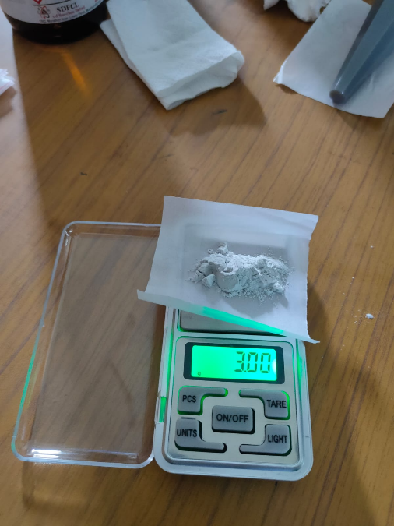 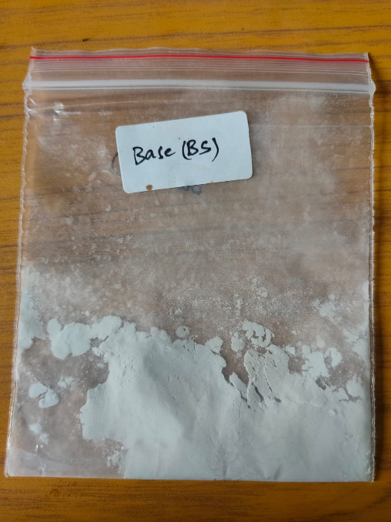

Figure 5.1 : Borosilicate(Base) Scaling Figure 5.2: Borosilicate(Base) Mixture

For the next sample, the composition of borosilicate is 90 percent of whole weight and calcined alumina is 10 wt %.Weighed through the scale  that will be 2.7 grams of borosilicate and 0.3 grams of alumina.

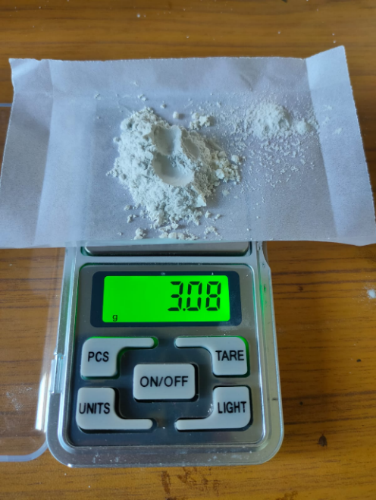 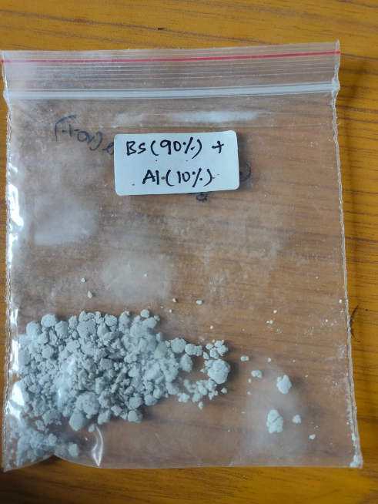

Figure 5.3: Borosilicate(90%)+Alumina(10%) Figure 5.4: Borosilicate(90%)+Alumina(10%) Scaling Mixture

Next sample will be borosilicate 80 wt% and calcined alumina 20 wt%. i.e as borosilicate will be 2.4 grams and 0.6 grams of calcined alumina.

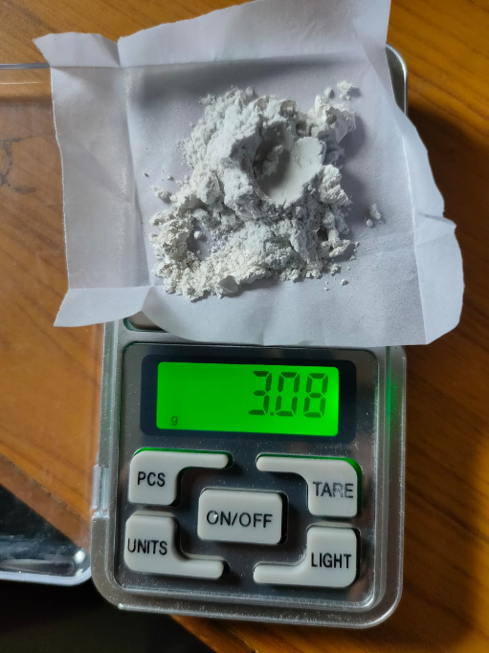 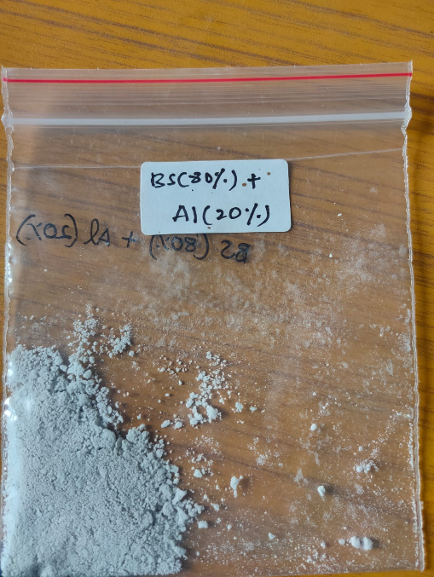

Figure 5.5 : Borosilicate(80%)+Alumina(20%) Figure 5.6 : Borosilicate(80%)+Alumina(20%) Scaling Mixture

In this fashion the following sample composites of 70 wt% borosilicate and 30 wt% of calcined alumina. The borosilicate with 2.1 grams and 0.9 grams of alumina.

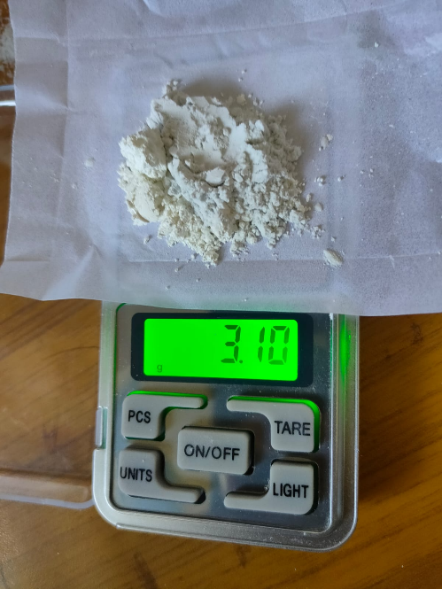 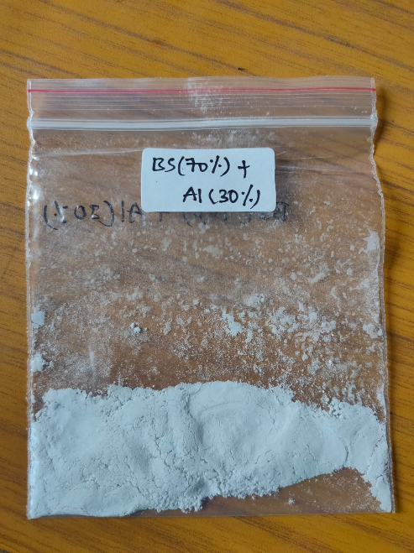

Figure 5.7: Borosilicate(70%)+Alumina(30%) Scaling Figure 5.8: Borosilicate(70%)+Alumina(30%) . Mixture

The composition is substituted alumina with Copper (II) oxide . In the following manner as the alumina, three more samples are scaled with ratios of 10 wt%,20 wt%, and 30 wt% of Copper oxide with rest of the borosilicate.

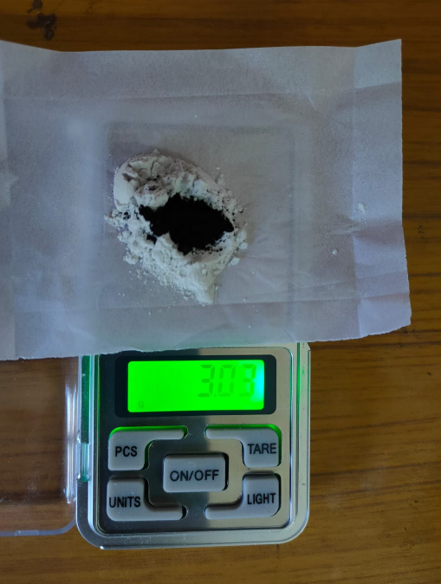 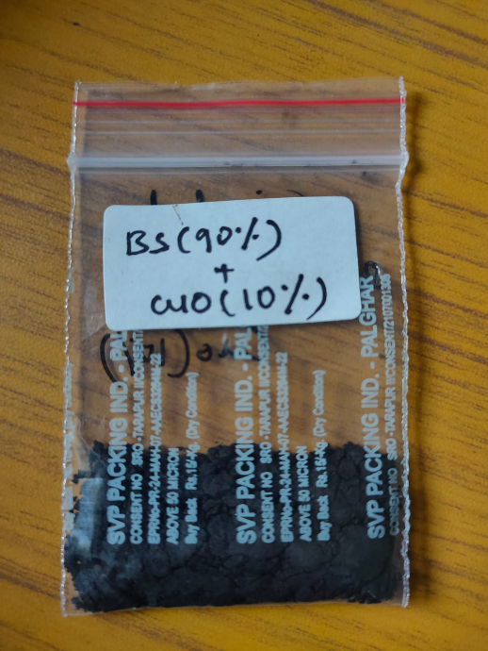

Figure 5.9: Borosilicate(90%)+Copper oxide(10%) Figure 5.10: Borosilicate(90%)+Copper oxide(10%) Scaling Mixture

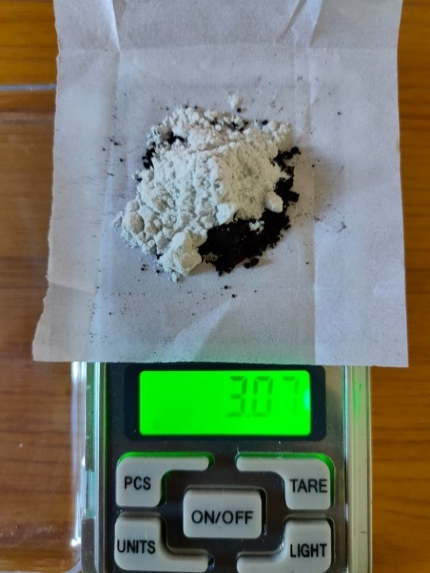 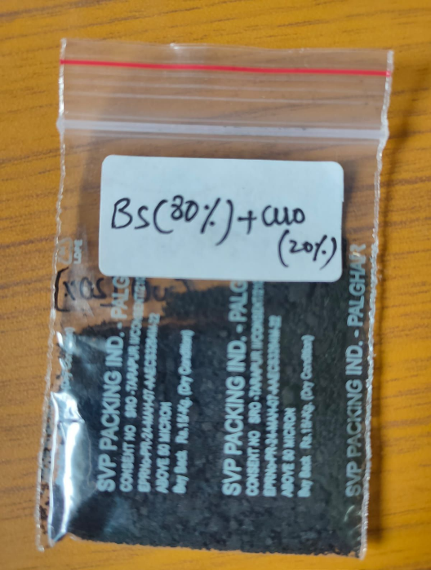

Figure5.11 : Borosilicate(80%)+Copper oxide(20%) Figure5.12: Borosilicate(80%)+Copper oxide(20%) Scaling Mixture

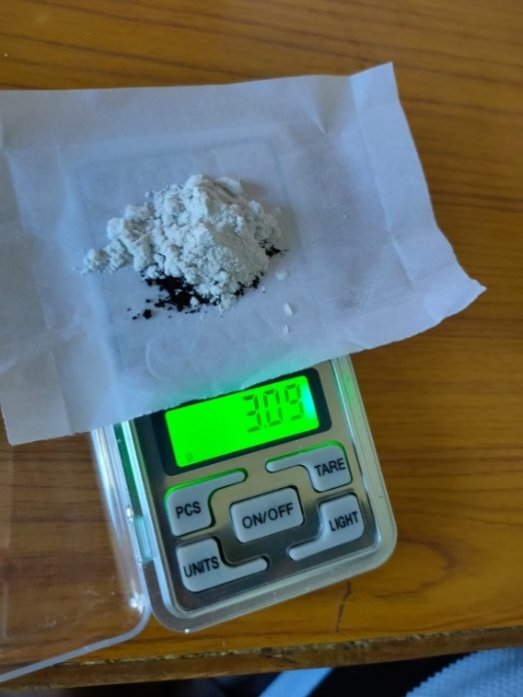 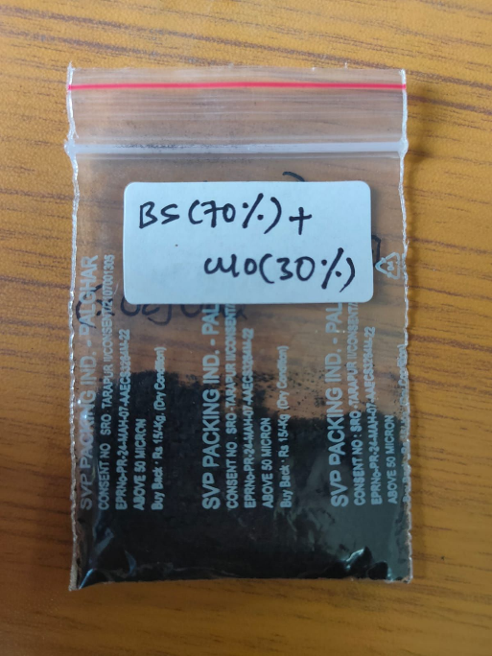

Figure 5.13 : Borosilicate(70%)+Copper oxide(30%) Figure 5.14 : Borosilicate(70%)+Copperoxide(30%) Scaling Mixture

The composition is constituted of all three materials as borosilicate, calcined alumina, and copper oxide. The composition comprises 10 wt% calcined alumina,10 wt% copper oxide, and the rest 80% of borosilicate, as 2.4 grams of borosilicate, 0.3 grams of alumina, and 0.3 grams of copper oxide.

# 5.1.2 Mixing:

After the scaling process, each sample is taken separately and grinded to mix well.  
  
The mixing process is done to manually amalgamate the different components of the composite. In this case, the mixture of (i) Borosilicate powder + (ii) Alumina powder, and, the mixture of (i) Borosilicate powder + (iii) Copper Oxide, to form the required composite materials.   
  
Once, the scaling process is done for the different weight ratios of the parent materials, the materials are poured in to a mortar and mixed with a pestle by hand. The mixing is done by hand for a time duration of 30 minutes.   
  
During the mixing process, the mixtures are added with ~5% distilled water for proper binding of the materials. When added with distilled water, the mixture of powders becomes slurry, but as it is mixed, the mixture absorbs the water content and comes to a paste-like consistency.

Each of the samples are mixed separately and then stored in pouches and left to dry overnight.

# 5.2 Grinding :

Once the samples are mixed and dried, they should be grinded with a binding agent to help the compaction of the sample. For the binding agent, PVA (Polyvinyl Alcohol) solution is used.   
  
5.2.1 Preparation Of PVA (Polyvinyl Alcohol) Solution:

The PVA in powdered form is mixed with distilled water to form a 2% PVA solution. The powder is added to distilled water and using a magnetic stirrer it is mixed with a gradual increase in temperature for about 5 hours. The solution has to reach a state of honey like consistency to be used for the binding process.

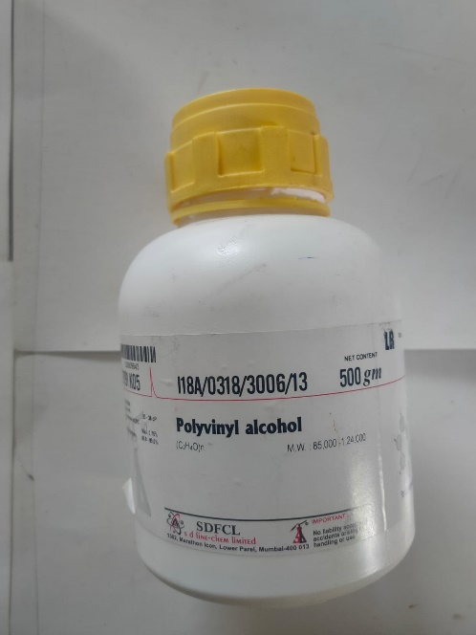 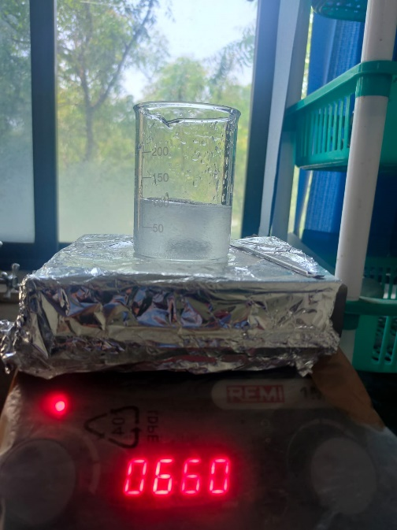

Figure 5.15: Polyvinyl alcohol Solution Figure 5.16 : PVA Solution preparation

# 5.2.2 Grinding:

In the grinding process, each dried sample is divided into 3 different samples, i.e. 1gm each for pellet preparation. These 1gm samples are taken separately into the motar and one drop of PVA solution is added to the mixture and grinded for about 2 minutes for proper binding of each 1gm sample.

After grinding, place each 1gm sample in a different pouch and place them in a dry place overnight.

# 5.3 Pellet Preparation:

IR FTIR XRF dies Set is used for the preparation of pellets. Die set is variable by the pellet size and volume, for this composite 10mm Die set is utilized. This device is used to compact the powder to the defined diameter. The pellet adjusts the height by the amount of powder added to the die set.

 Initially, all respective parts are cleaned by distilled water and also rinsed with acetone for no chemical reactions with any other materials. This process is done in the following steps

1. First die sleeve is placed upon the bottom die.

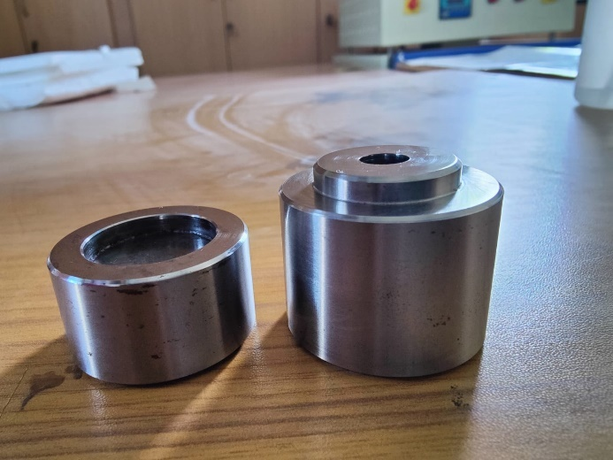

Figure 5.17: Die sleeve and bottom die

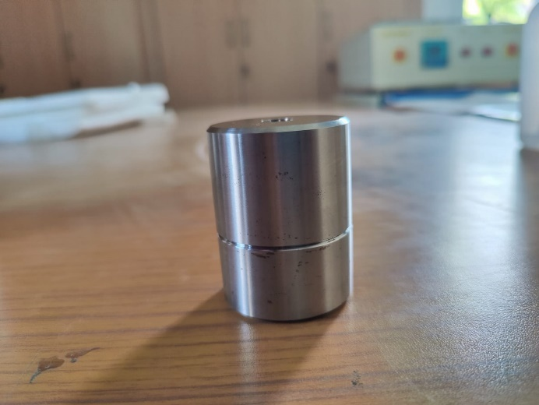

Figure 5.18 : Combined Bottom die and Die sleeve

2. Now die core is dropped in the die sleeve and with the help of a tweezer settled the core to the bottom

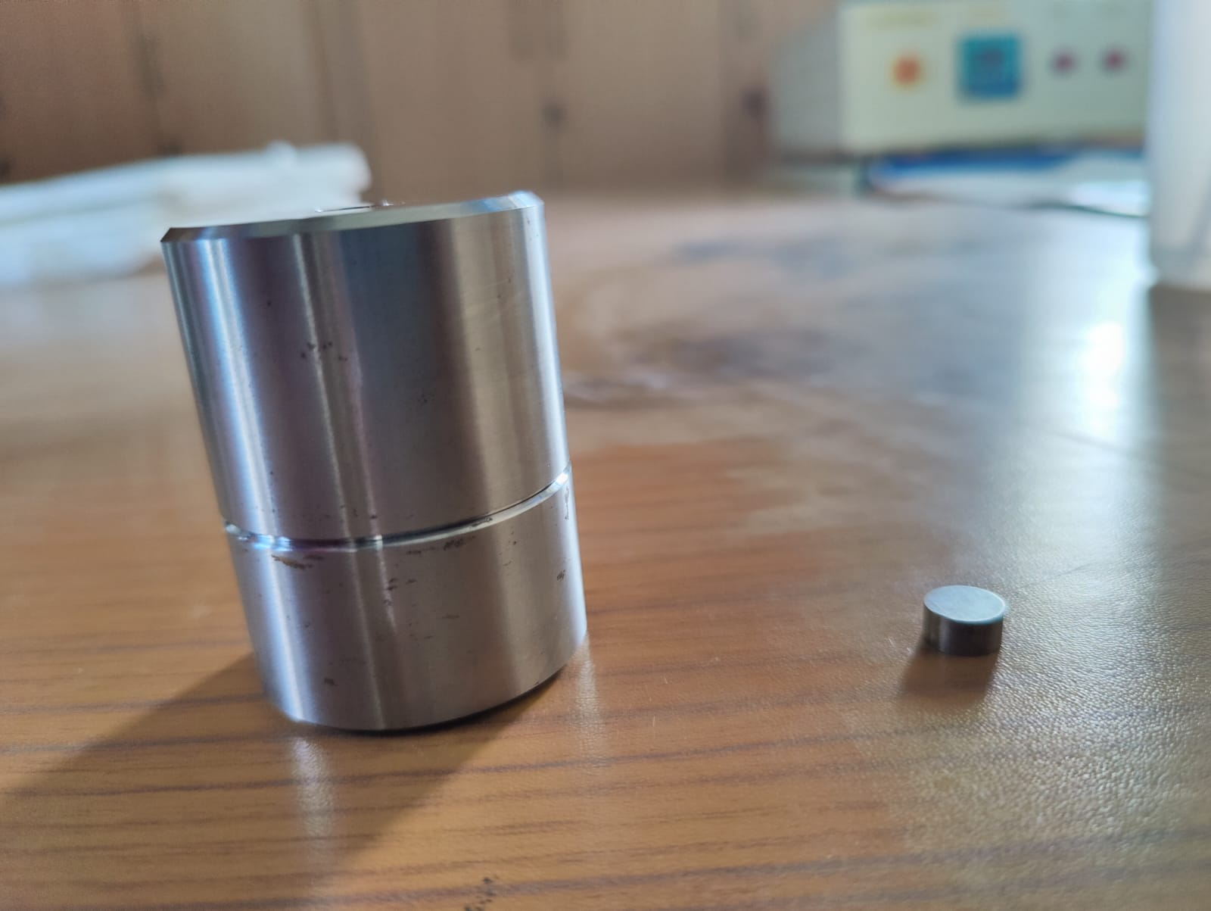

Figure 5.19: Die core and die sleeve

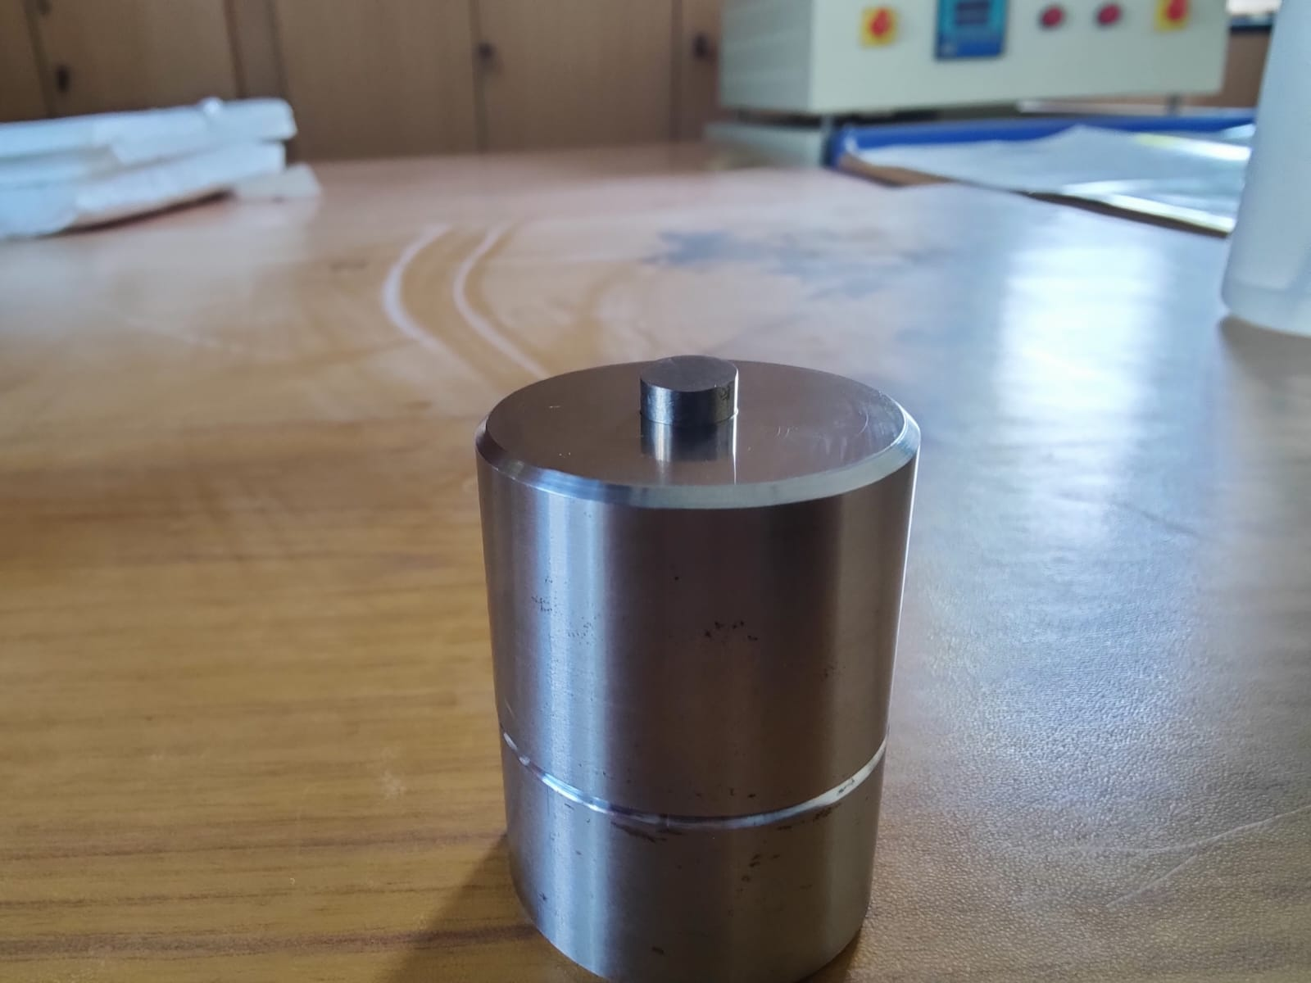

Figure 5.20: Die core is locked in the die sleeve

3. Add the composite material to the die sleeve and pushed it with the top pushing rod to compact the powder

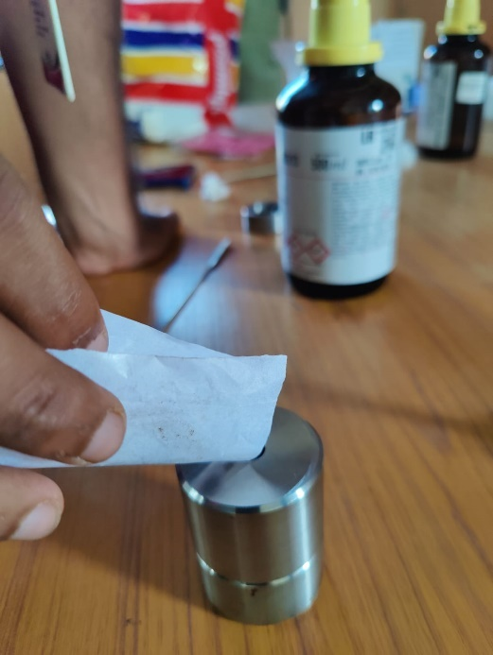

Figure 5.21: Composite Material is added

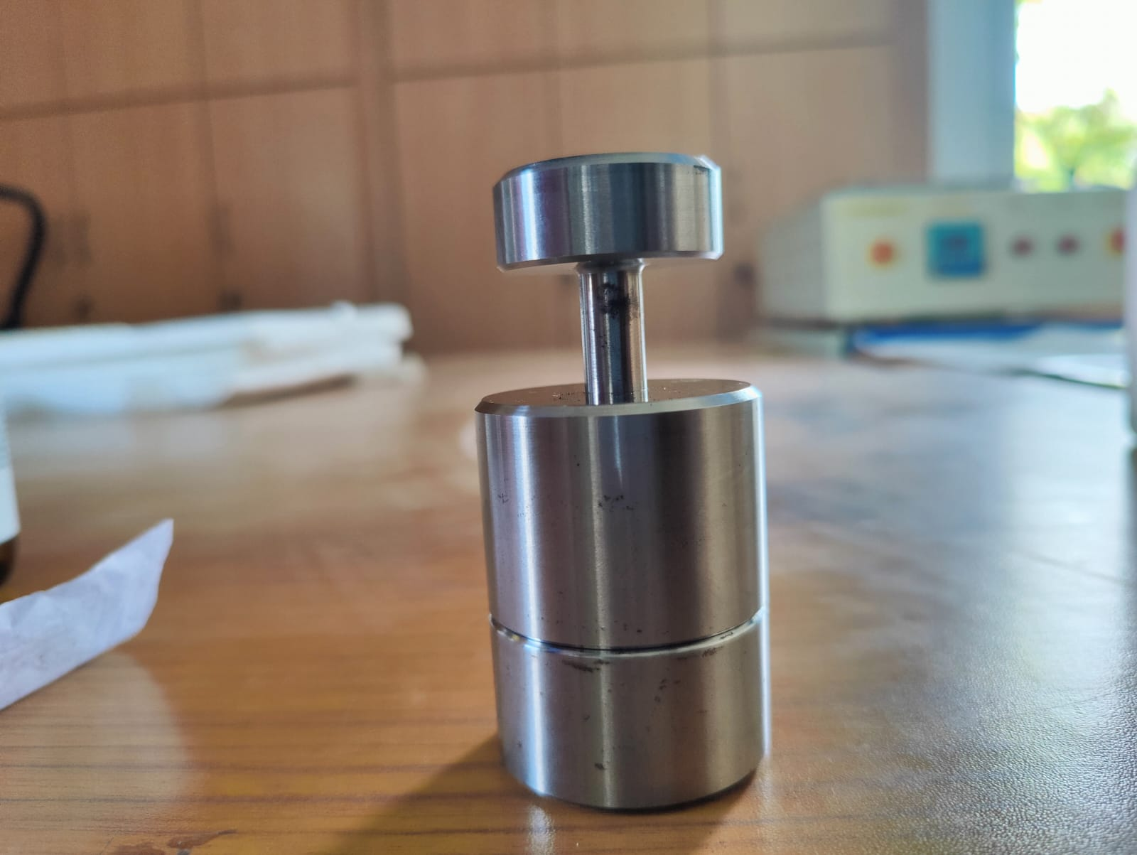

Figure 5.22: Pushing Rod is Connected to die sleeve

4.Now placed it within the Hot Press unit and applied the load upon the die unit.

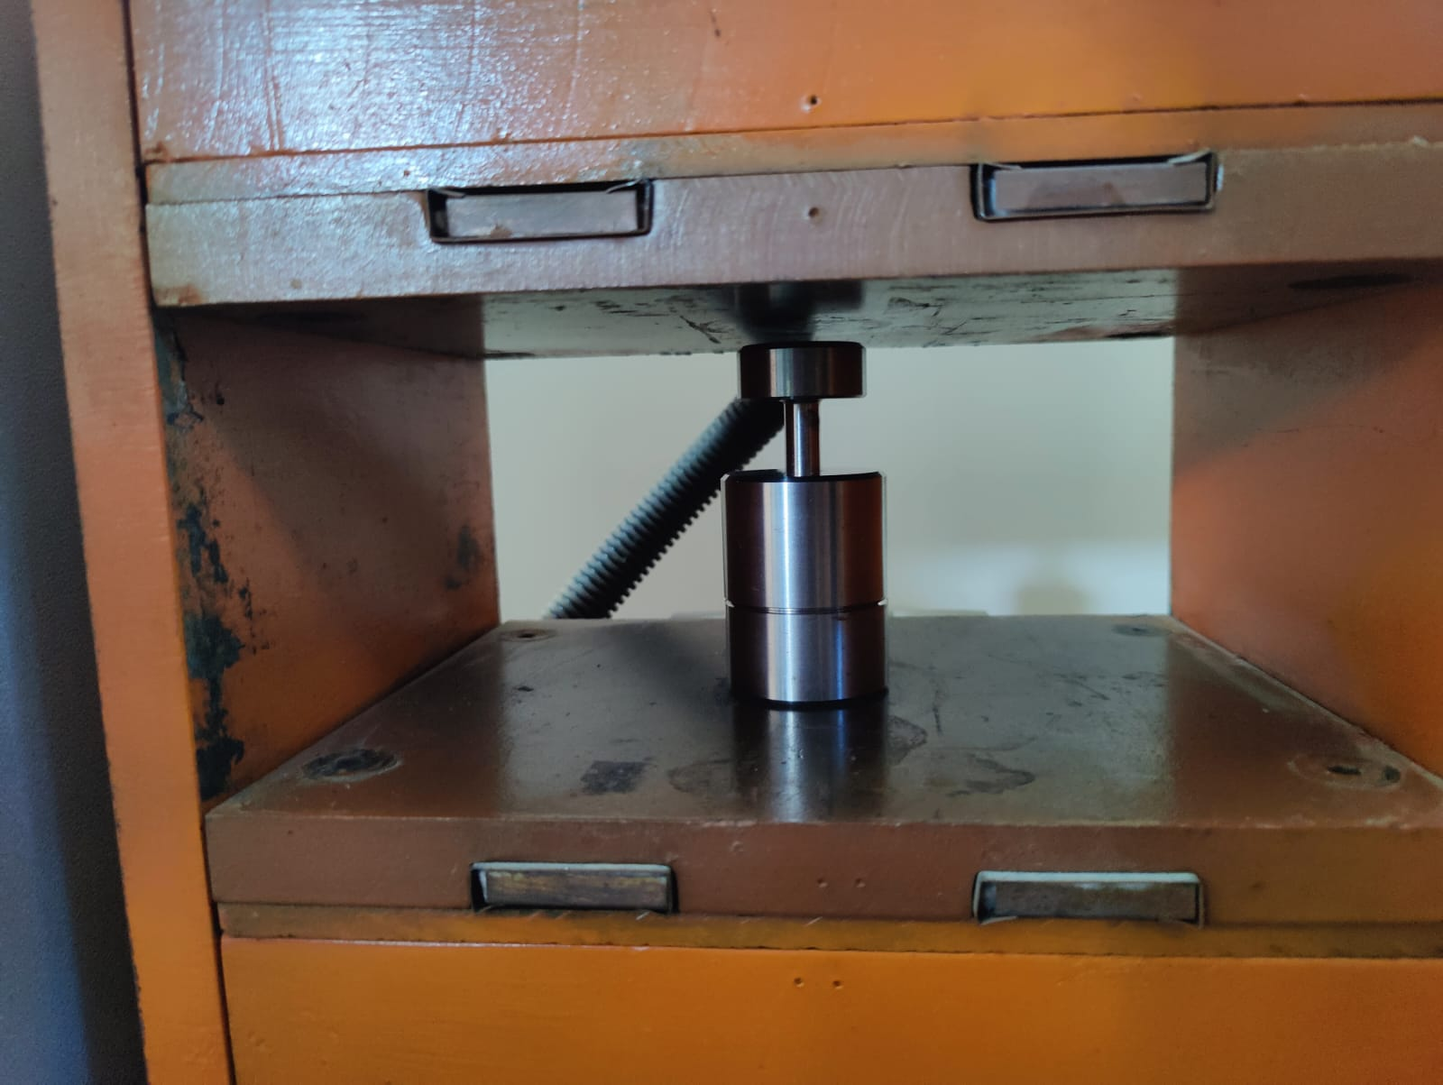

Figure 5.23: Die sleeve is locked under Hydraulic Press

5.After enough load applied on the die unit,50kgf pressure is applied upon the die set through the hand bar

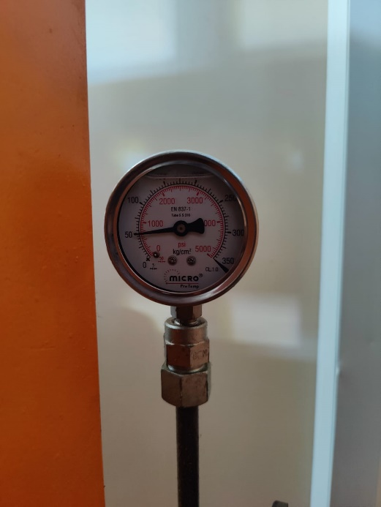 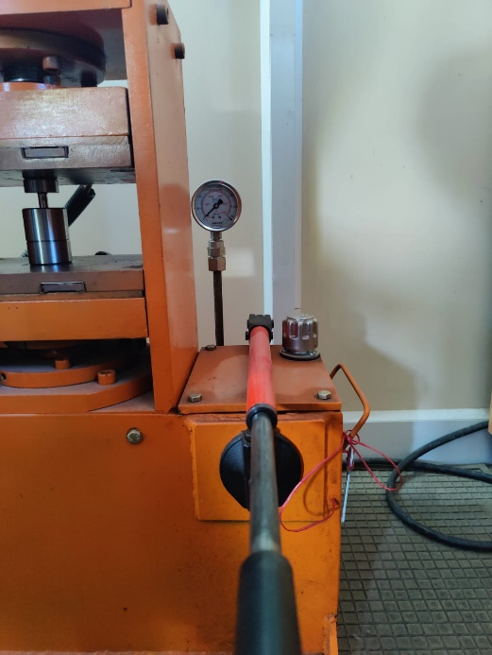

Figure 5.24: 50 Kgf Pressure is maintained Figure 5.25 : Hand bar setup

6. Reaching 50 kgf pressure locked the pressure chamber and left it for 2 minutes.

7.After 2 minutes, released the pressure and load upon the die set.

8. Now the bottom die is removed and mould remover is put beneath the die sleeve .

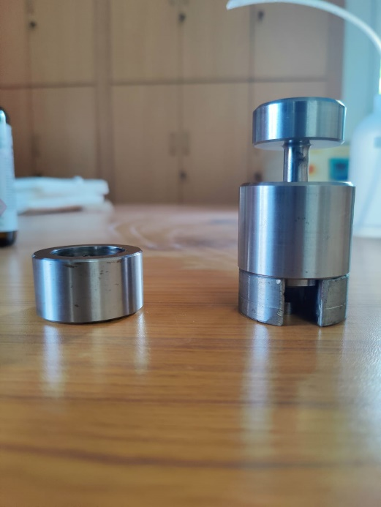

Figure 5.26 : Mold remover and die sleeve

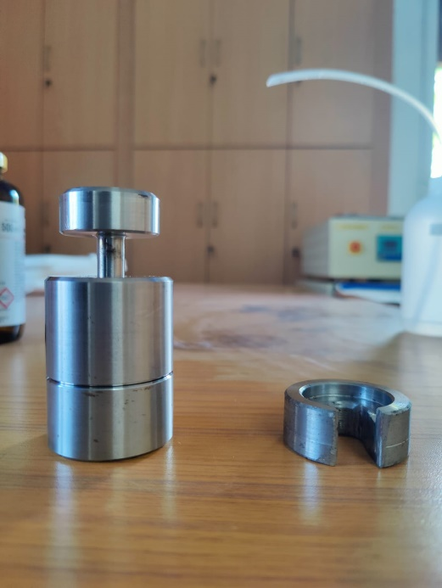

Figure 5.27: mold remover is put under die sleeve

9. Again placed the die set in the hot press unit and applied load until the mould separated from the die set

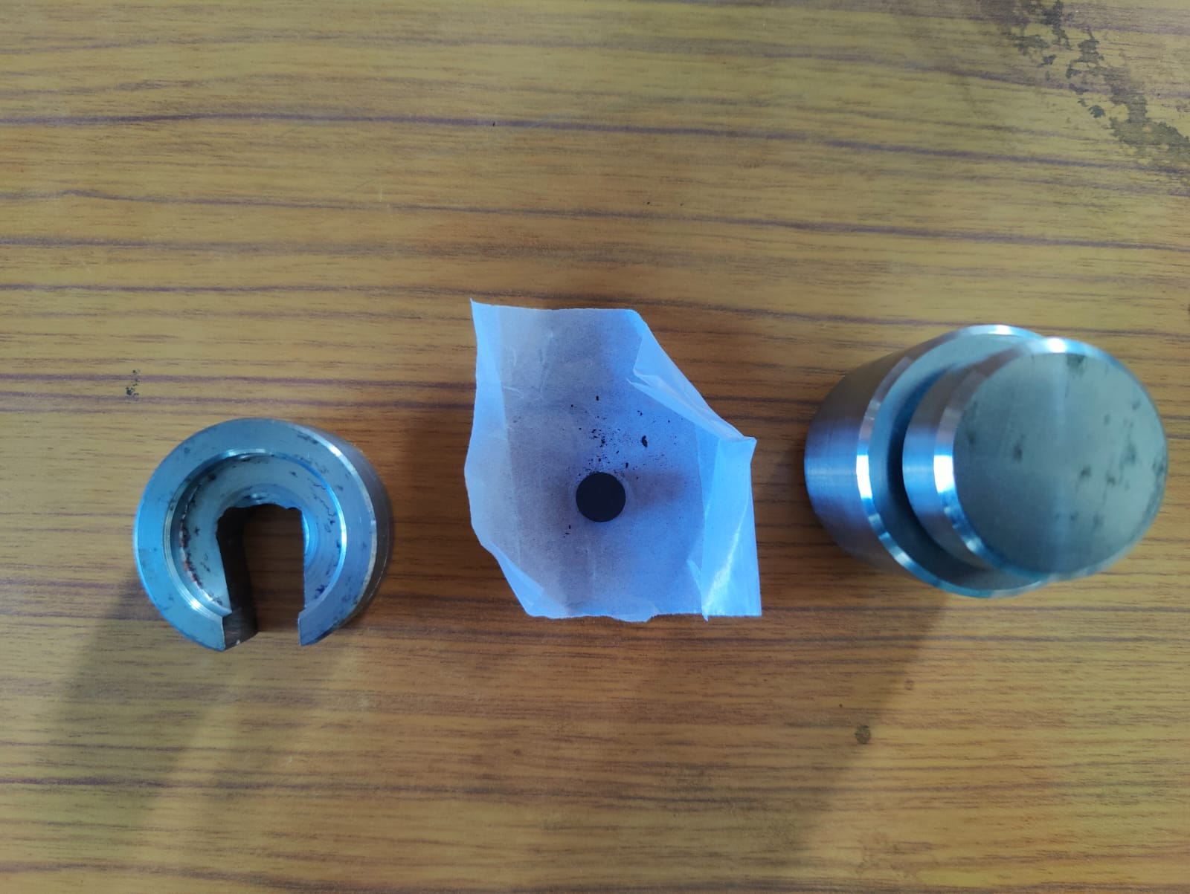

Figure 5.28: Pellet is separated from die sleeve

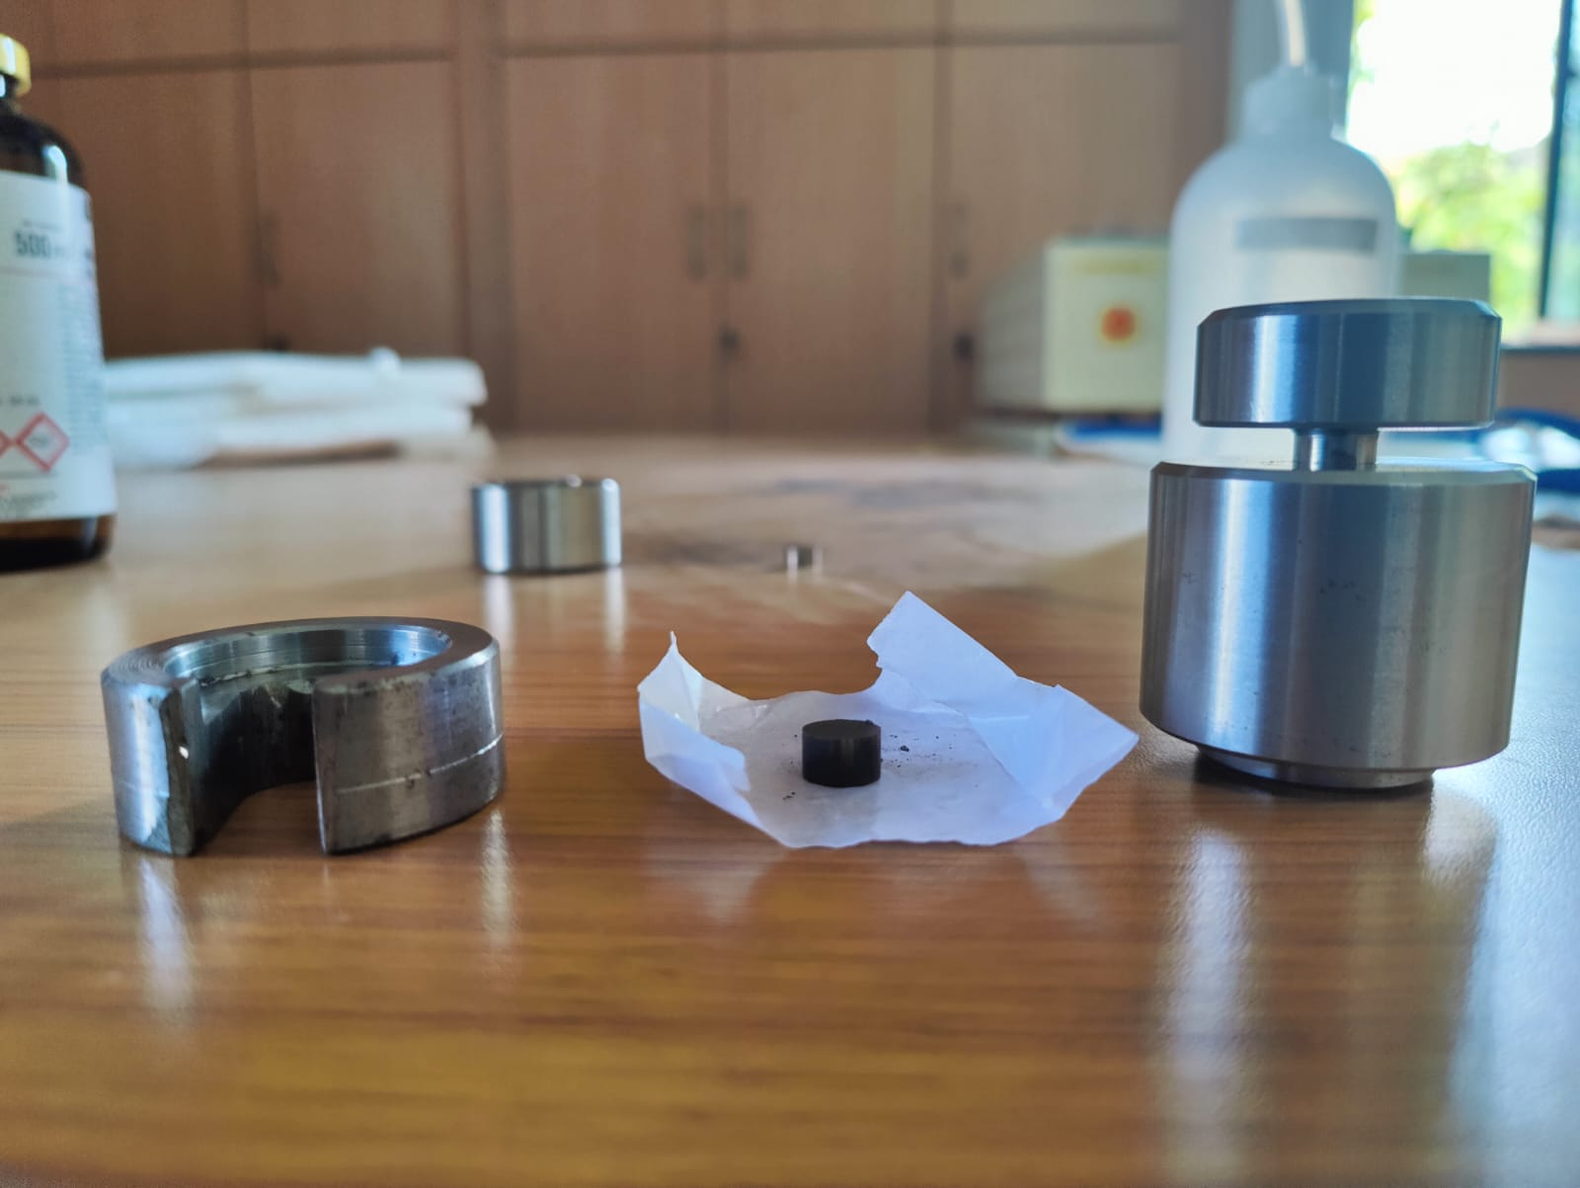

Figure 5.29: Pellet is separated from die sleeve

10. Carefully located the pellet and labeled it.

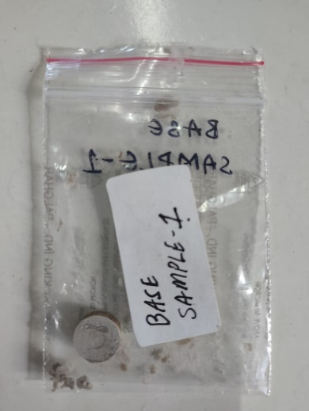 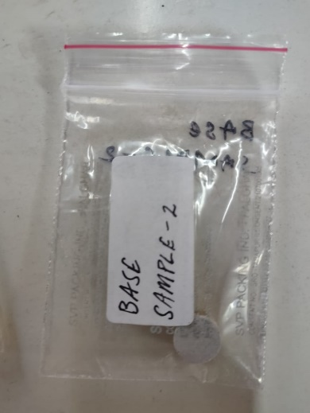 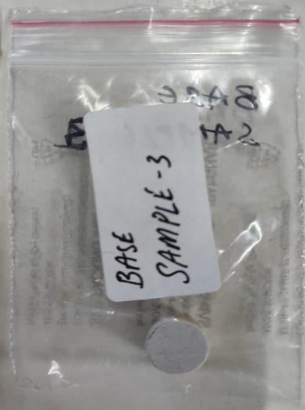

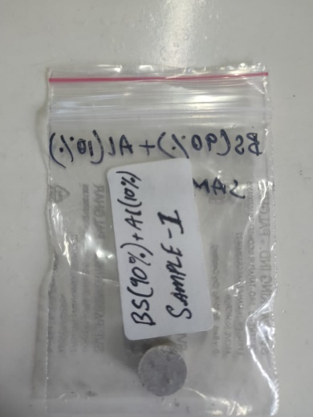 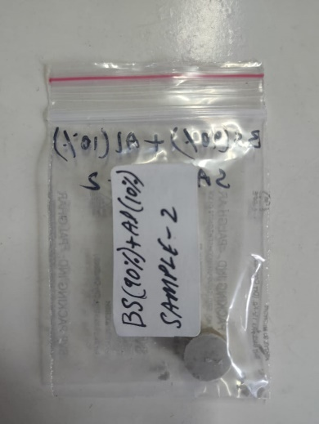 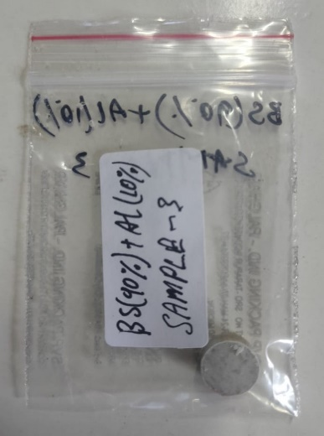

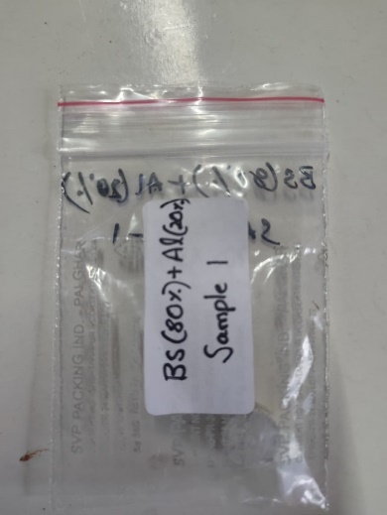 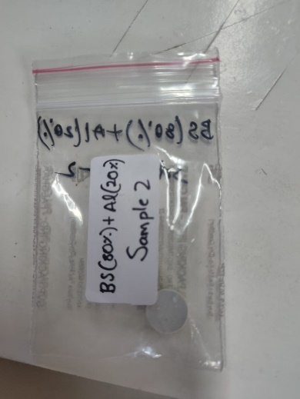 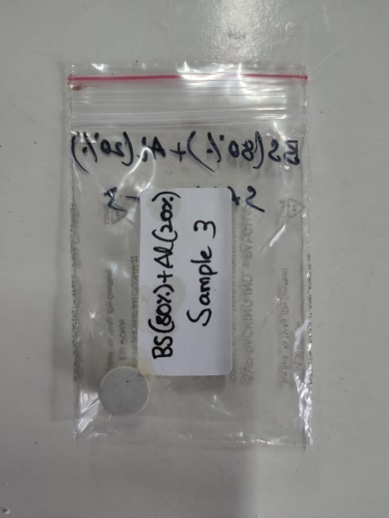

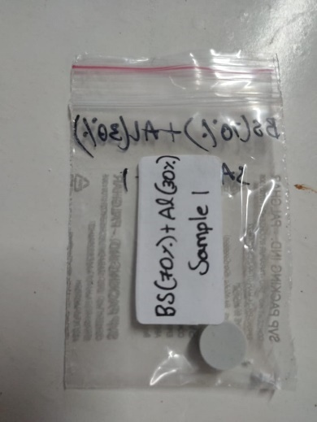 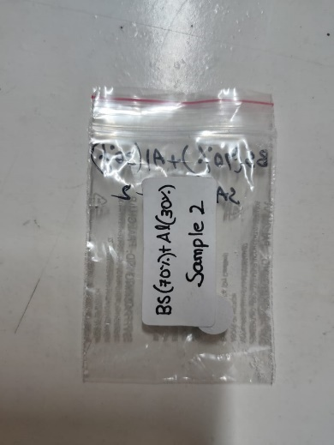 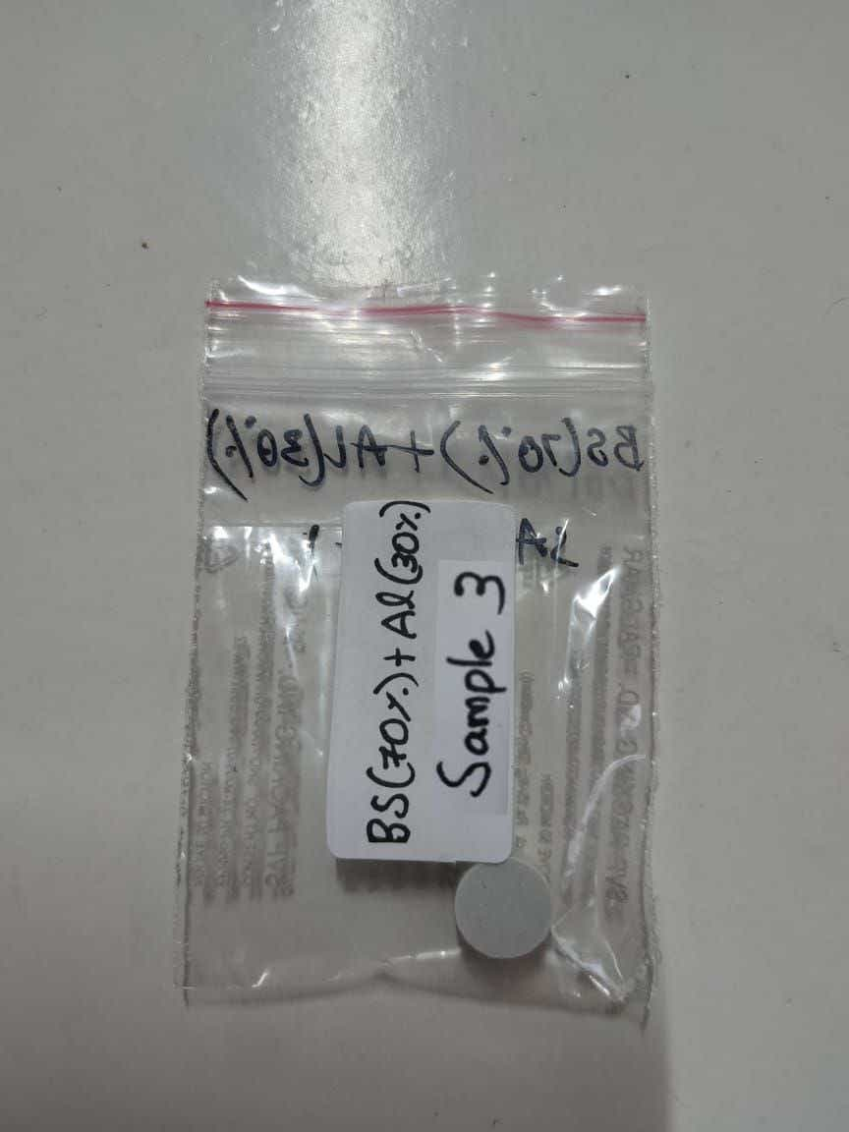

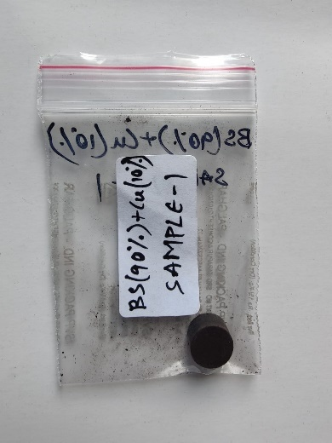 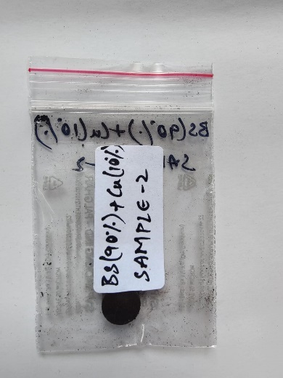 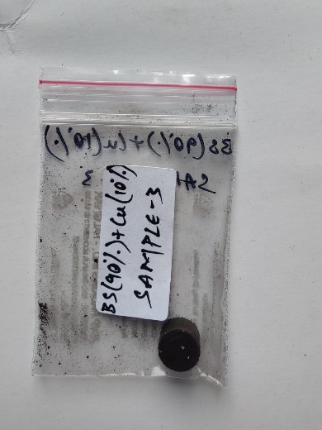

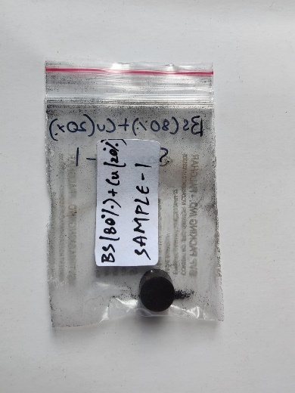 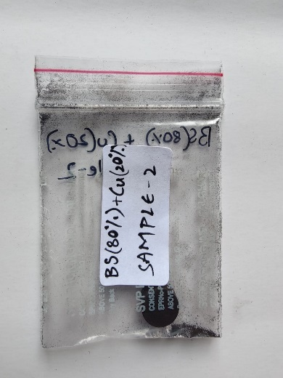 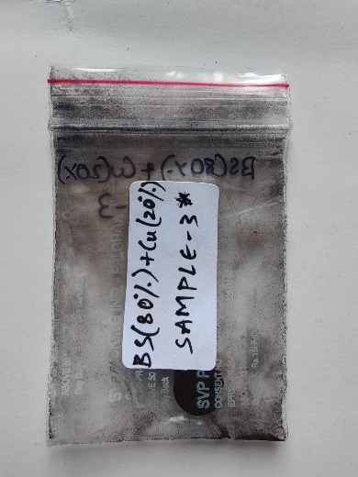

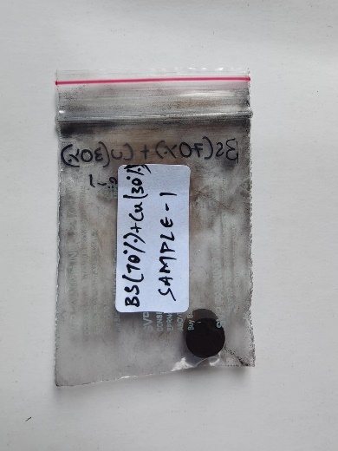 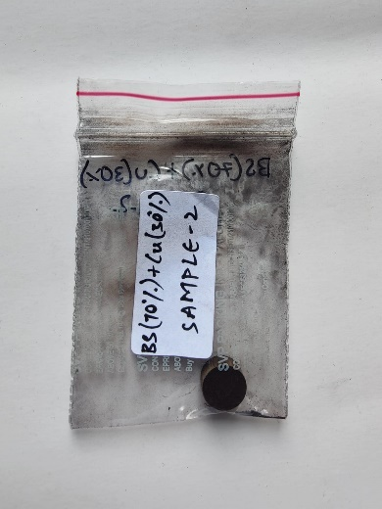 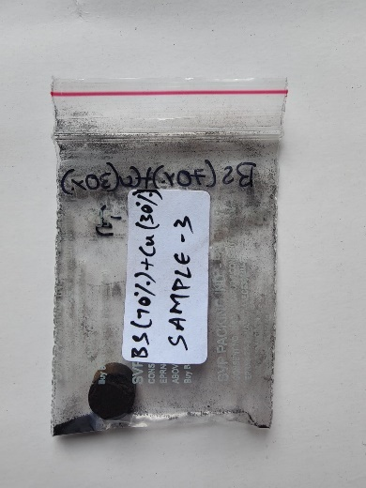

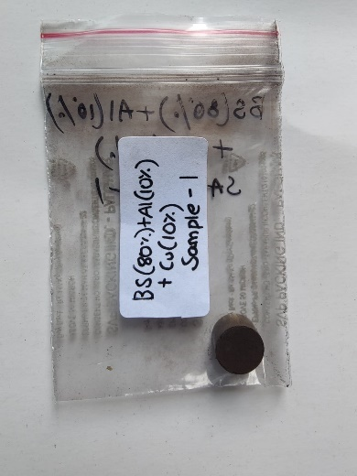 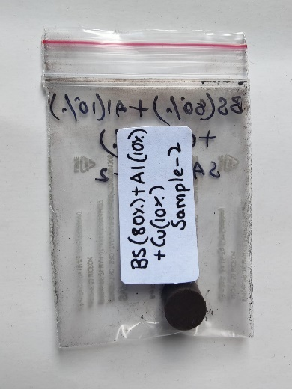 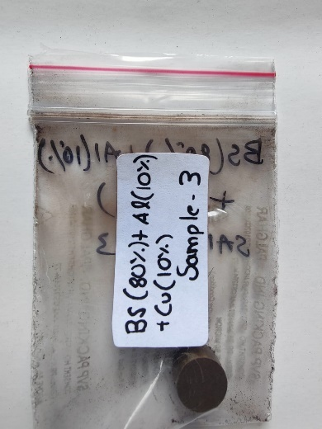

Figure 5.30 : Above are pellet picture of all 24 samples neatly labeled and locked

# 5.4  Sintering:

After preparing the pellets in the compaction device, the pellets are heated at high temperature that is below the melting point of all components of the composite material. In powder metallurgy, during sintering process, the powder particles are bonded together through the amalgamation of solid-state diffusion and surface melting. The powder particles become more mobile as a result of the heating, which enables them to disperse and connect with one another at the sites of contact. This results in a solid mass along with improved physical and mechanical properties such as hardness, toughness, etc.

The pellets prepared as discussed above, are sintered in an oven at 850°c for 30 minutes inorder to prepare the pellets as solids. The oven is programmed specifically to heat the pellets in a certain order to make sure that solidification happens correctly. The heating process for these pellets is as follows:

1. The pellets are placed in the oven batch-wise.

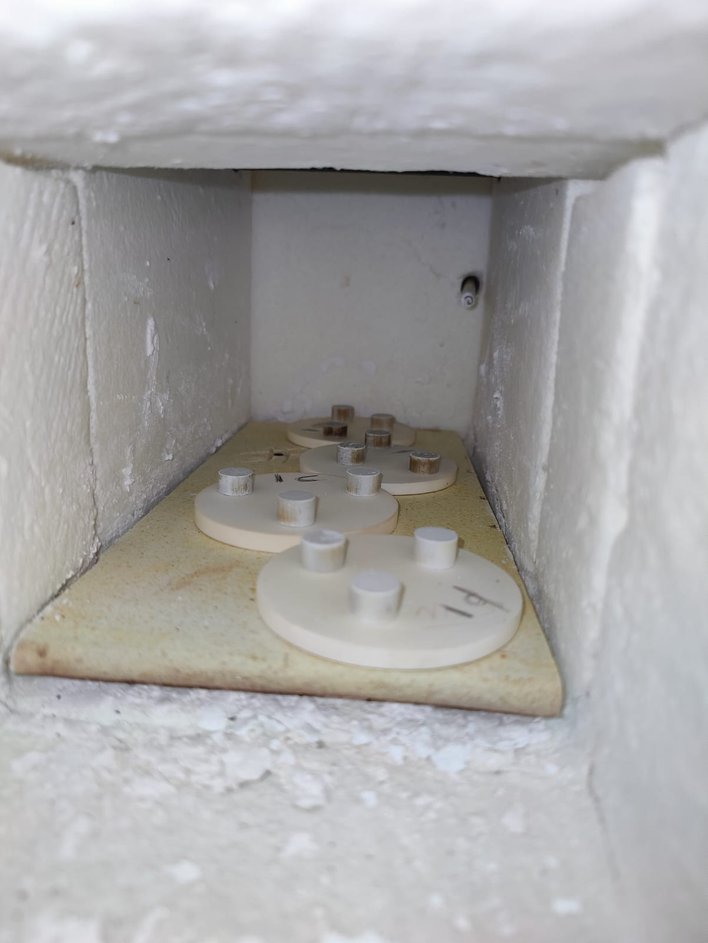

Figure 5.31: Pellets are placed inside the Oven

1. The oven is programmed.
2. Initially, the oven reaches 300°c from room temperature at a faster pace.

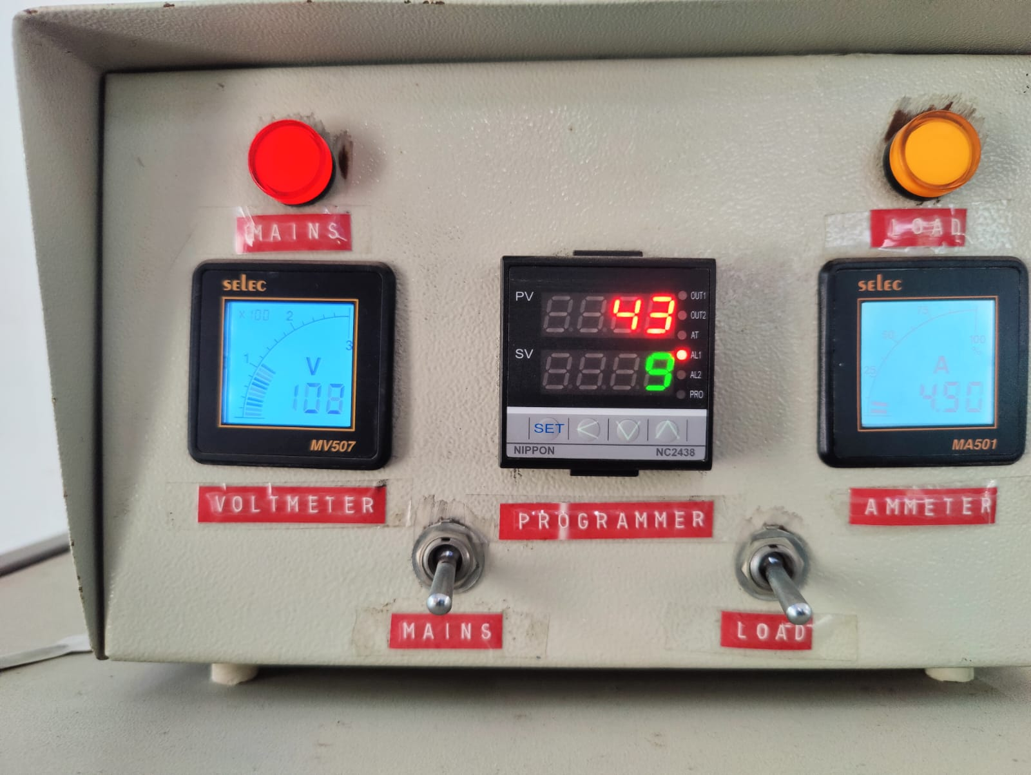

Figure 5.32: Initial Temperature o furnace

1. After reaching 300° C it is maintained for 20 minutes.

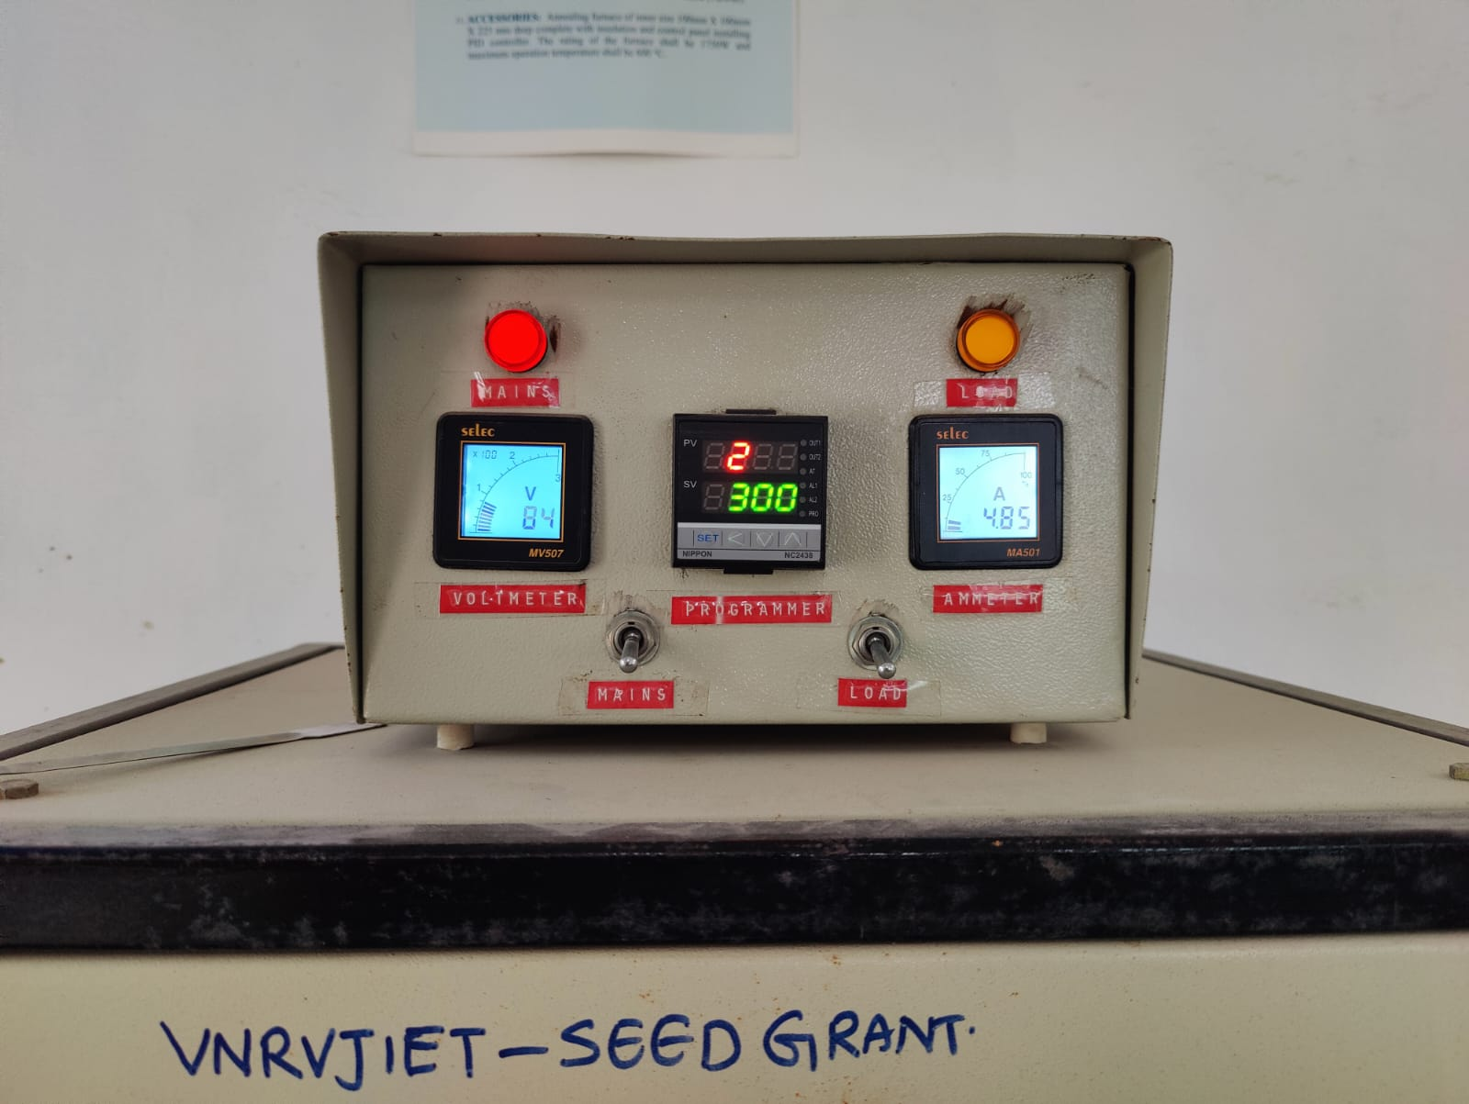

Figure 5.33: Furnace at 300° C

1. After the 20 minutes are completed, the temperature will be gradually increased at the rate of 5°c per minute until it reaches 850°c.i.e is 110 minutes
2. After reaching 850°c, the same temperature is maintained for about 30 minutes for complete curing to take place.

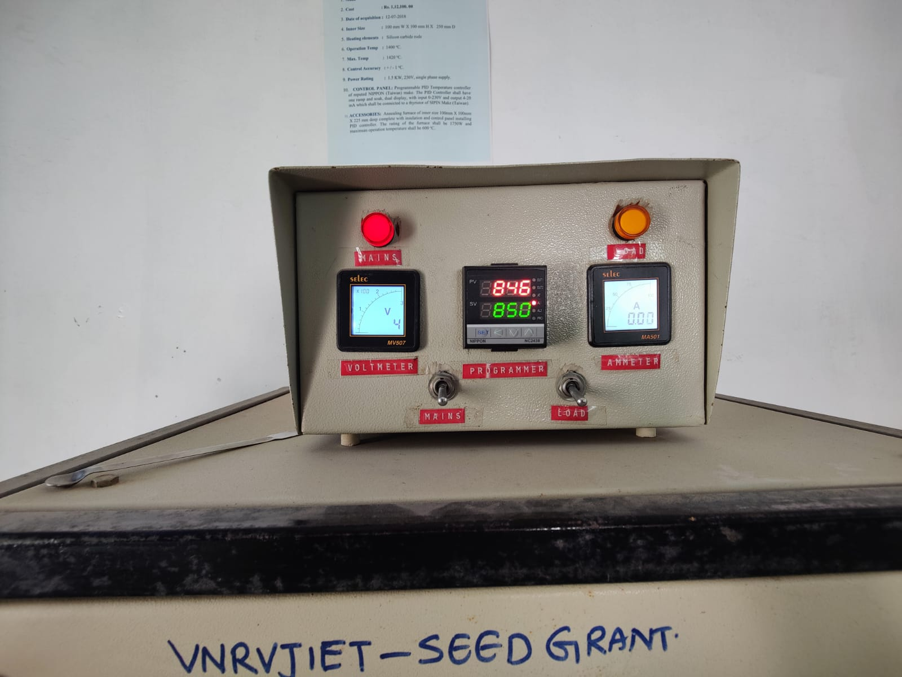

Figure 5.34 : Furnace at 850° C

1. Following the curing process, the oven temperature reduces back to 300°c at 5°c per minute.
2. The oven is now turned off and the pellets are allowed to cool naturally overnight in the oven to form perfect pellets.

# CHAPTER -6

# RESULTS AND DISCUSSIONS

Sintering process generally results in higher hardness and strength as the grain growth helps the composite become more compact and stronger. The grain growth increases the grain size of the Micro particles of the Borosilicate and Alumina and the Nanoparticles of the Copper Oxide which increases the density of the pellet as the size of the pellet is constrained. The compaction and sintering process results in a dense sample that can be used to test the properties of the composite material.

For the composite prepared, in this scenario, the tests performed are Micro Vickers Hardness, Optical Microscope at 200x, and Scanning Electron Microscopy. These tests performed on the composite material provided the following results that justify the project.

# 6.1 Micro Vickers Hardness:

Micro Vickers Hardness is an alternate hardness testing method developed to test the hardness of materials. This is an easier method than other hardness tests as the calculations do not depend on the indenter as the indenter can be used for all materials irrespective of hardness. The basic principle, as with all common measures of hardness, is to observe a material's ability to resist plastic deformation from a standard source. The units of hardness are given by Vickers Pyramid Number (HV) and this can be converted to Pascals.

The test method used is ASTM E 384-16/ ASTM E 140 and the equipment used is Ecnomet VH-1MDX. This test provided the following result: (BS-Borosilicate, Al2O3 -Alumina, Cu2O- Copper Oxide)

|  |  |  |
| --- | --- | --- |
| **Sample ID** | **Hardness Value(HV0.3)** | **Avg. Hardness Value (HV)** |
| BS 100% | (548, 554, 544) HV0.6 | 548.66 |
| BS 90% + Al2O3 10% | (691, 705, 700) HV0.3 | 698.66 |
| BS 80% + Al2O3 20% | (537, 459, 511) HV0.7 | 502.33 |
| BS 70% + Al2O3 30% | (346, 313, 335) HV0.8 | 331.33 |
| BS 90% + Cu2O 10% | (389, 418, 436) HV0.4 | 414.33 |
| BS 80% + Cu2O 20% | (518, 477, 498) HV0.10 | 497.66 |
| BS 70% + Cu2O 30% | (556, 589, 563)  HV0.9 | 569.33 |
| BS 80% + Al2O3 10% + Cu2O 10% | (580, 619, 588) HV0.5 | 595.66 |

Table 3: Micro Vickers Hardness Test results

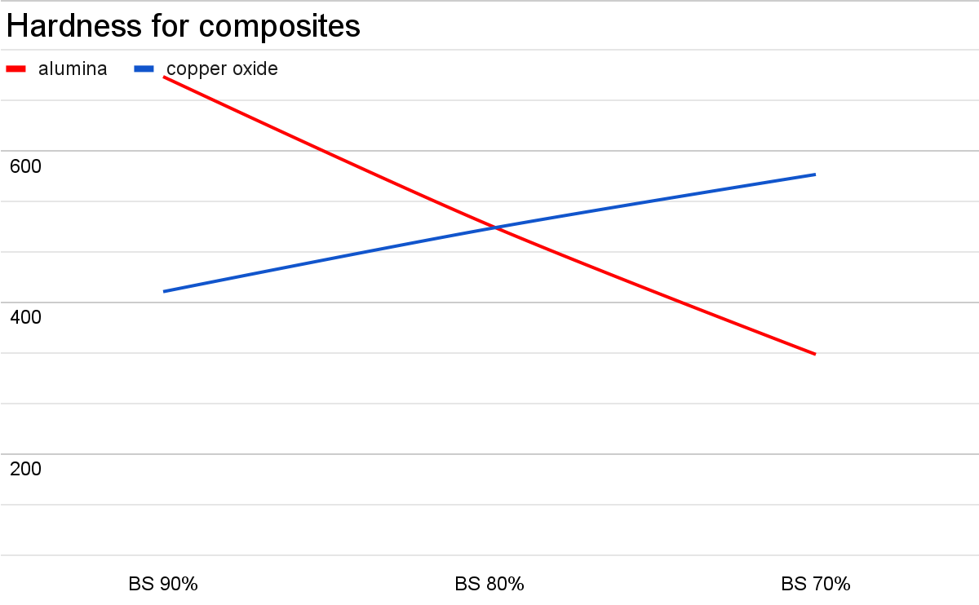

Figure 6.1: Bar graph on Hardness test results

rom the obtained results, we understand that the hardness of the composite formed by BS 90% and Al 10% has the highest hardness results. These results show the best possible composition of the materials. Comparison of the various compositions of Borosilicate, Alumina, and Copper Oxide gives us a clearer idea of the changes in the hardness properties of the materials.   
  
 The next highest hardness is seen in the combination of the 3 materials, Borosilicate (80%), Alumina (10%) and Copper Oxide (10%) with an Avg. hardness of 595.66 HV.

The Hardness values of the composites with varying compositions show that the follow a trend when other materials are added to Borosilicate. The trends are as follows:

* When 10% Alumina (Al2O3) is added to Borosilicate, the hardness value increases drastically by 150HV and as the Alumina further added by 20% and 30%, the hardness value is lower than 100% BS.
* When 10% Copper Oxide (Cu2O) is added to Borosilicate, the hardness value reduces by 134.33HV, but when Copper Oxide is further added by 20% and 30%, the hardness values increase and at 30% Cu2O, the hardness value is slightly greater than 100% BS.
* When 10% Alumina (Al2O3), 10% Copper Oxide (Cu2O) and 80% Borosilicate are combined, the hardness value has increased by 47HV, as compared to 100% Borosilicate.

From the above observations, we infer that an addition of 10% Alumina (Al2O3) and >10% Copper Oxide (Cu2O) with Borosilicate, will give a high hardness value as is required.

# 6.2 Structural Analysis Through Optical Microscope:

The Prepared Compositons are observed through Optical microscope, the results are as follows:

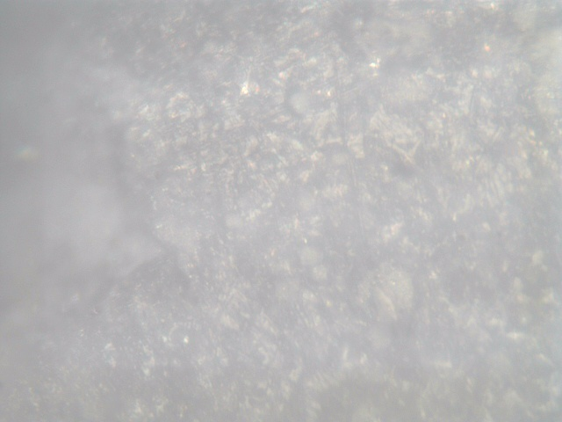

Figure 6.2: Borosilicate(100%)

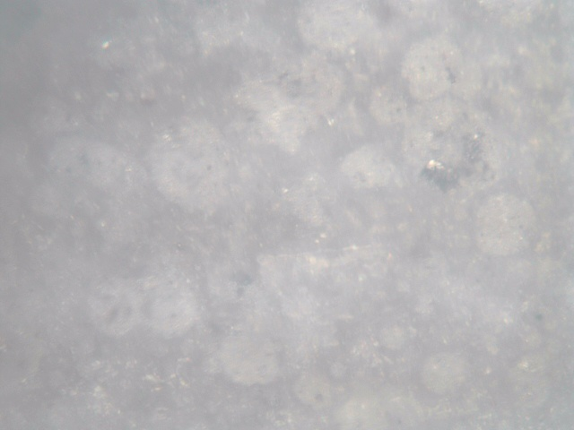

Figure 6.3: Borosilicate (90%)+ Alumina(10%)

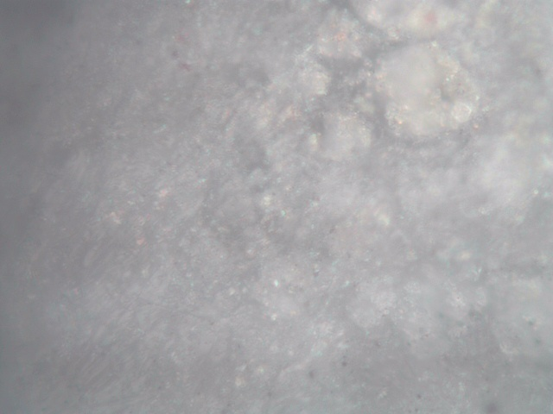

Figure 6.4: Borosilicate(80%)+ Alumina(20%)

**

Figure 6.5: Borosilicate(70%)+ Alumina(30%)

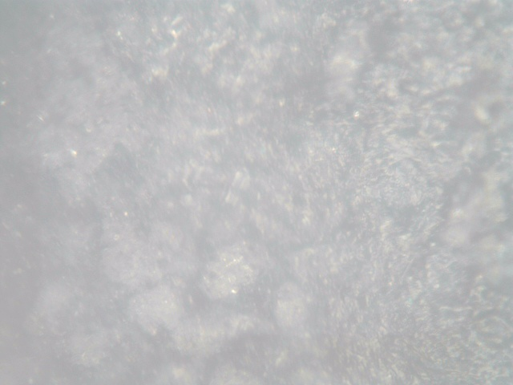

Figure 6.6: Borosilicate(90%)+ Copper oxide(10%)

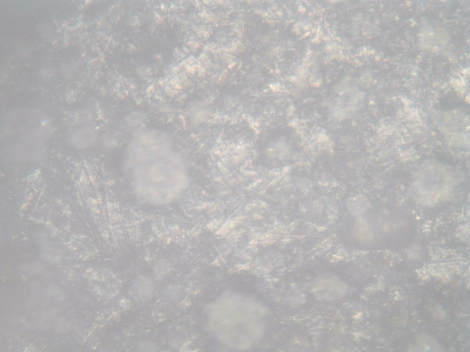

Figure 6.7: Borosilicate(80%)+ Copper oxide(20%)

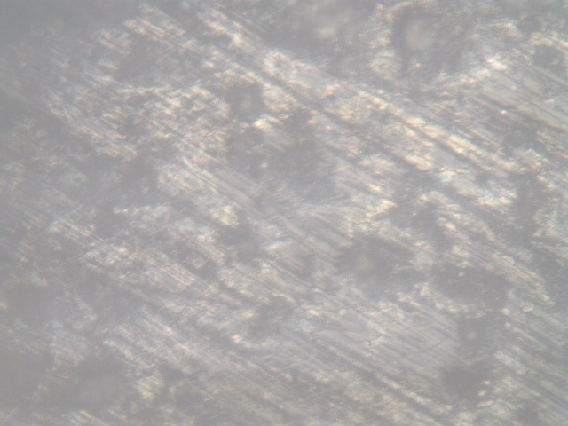

Figure 6.8: Borosilicate(70%)+ Copper oxide(30%)

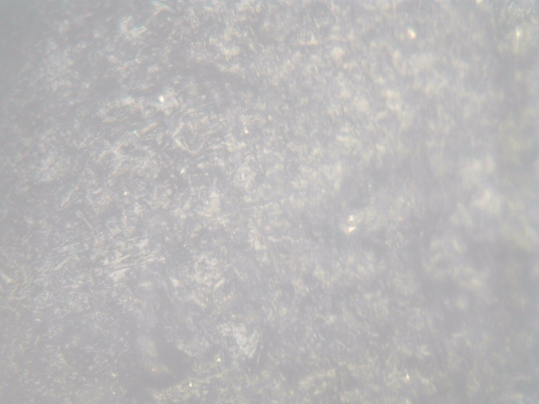

Figure 6.9: Borosilicate(80%)+Alumina(10%)+ Copper oxide(10%)

The above images depict the Structure of the composite materials at 200x magnification done by using an Optical Microscope. This observation helps in the classification of the composites and also helps determining the surface structure of the composite material. By observing through the optical microscope, we can determine various surface features of the material and also check for defects. The above images are given for reference of the same.

## 6.3 Microstructural Analysis Through Scanning Electron Microscopy:

The Scanning Electron Microscope (SEM) analysis has been performed on the composite material in order to study and observe the microstructure of the pellets. This analysis gives us the microstructure of the pellets at the measure of microns that help in understanding the structures of the various materials present. This microstructure is attained due to the sintering process performed on the pellets for about 30 minutes at 300°c and 30 minutes at 850°c resulting in grain growth. The following 4 samples have been analysed by SEM analysis:

a) Base - 100% Borosilicate

b) 80% BS + 20% Al2O3

c) 80% BS + 20% Cu2O

d) 80% BS + 10% Al2O3 + 10% Cu2O

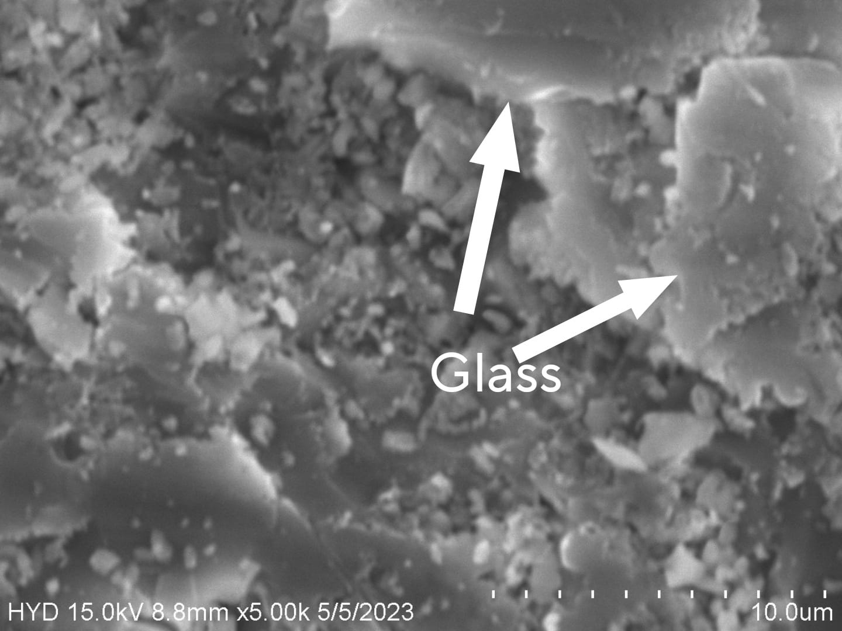

Figure 6.10: SEM image of Borosilicate (100%)

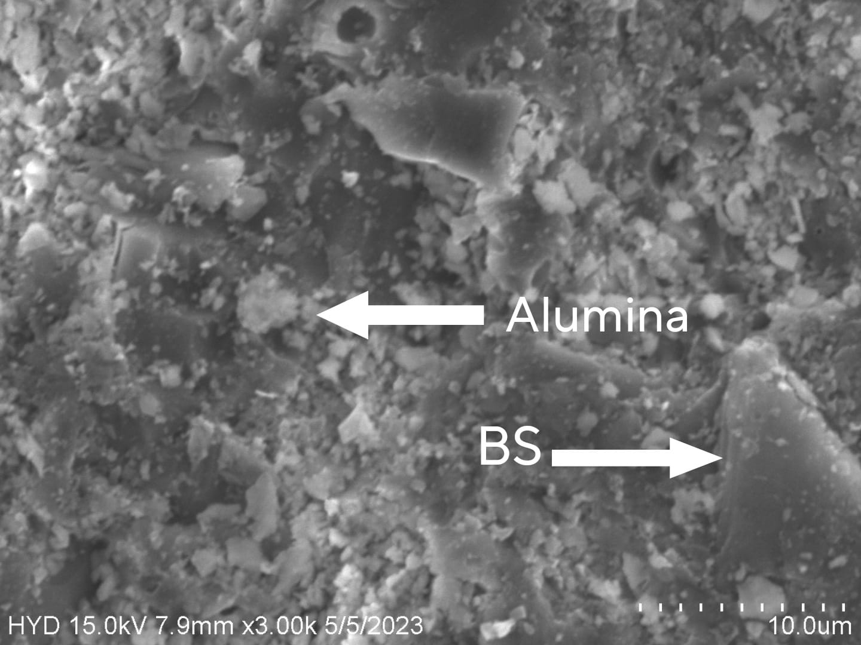

*Figure 6.11: SEM image of Borosilicate (80%)+ Alumina(20%)*

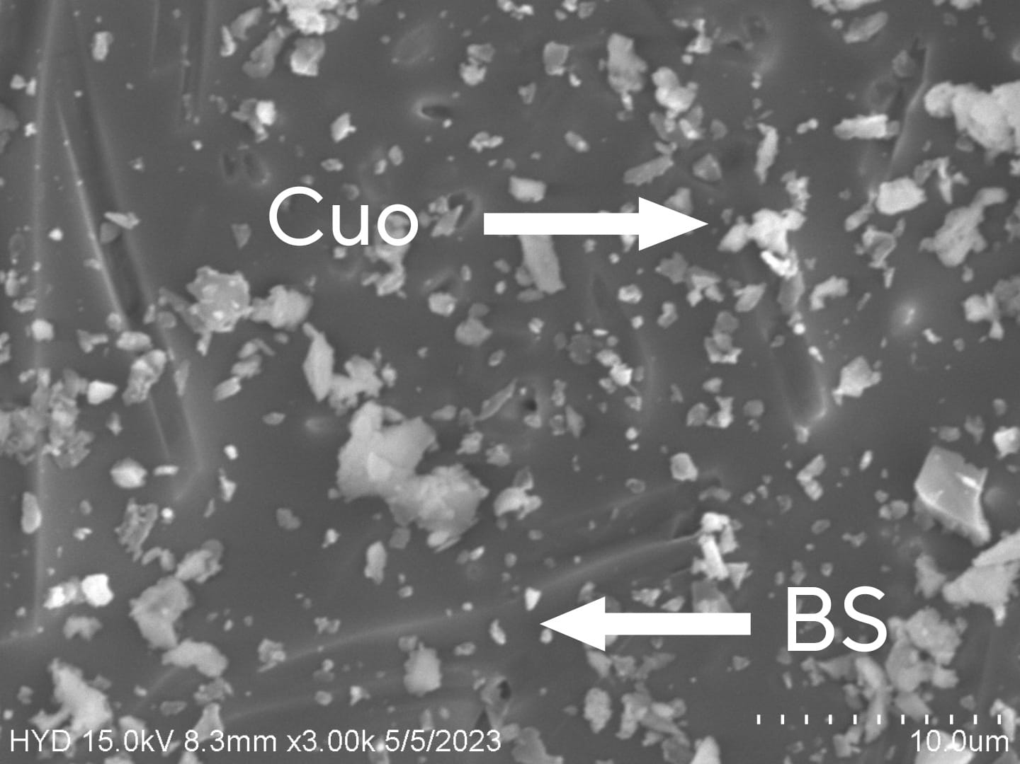

Figure 6.12: SEM image of Borosilicate (80%) + Copper oxide(20%)

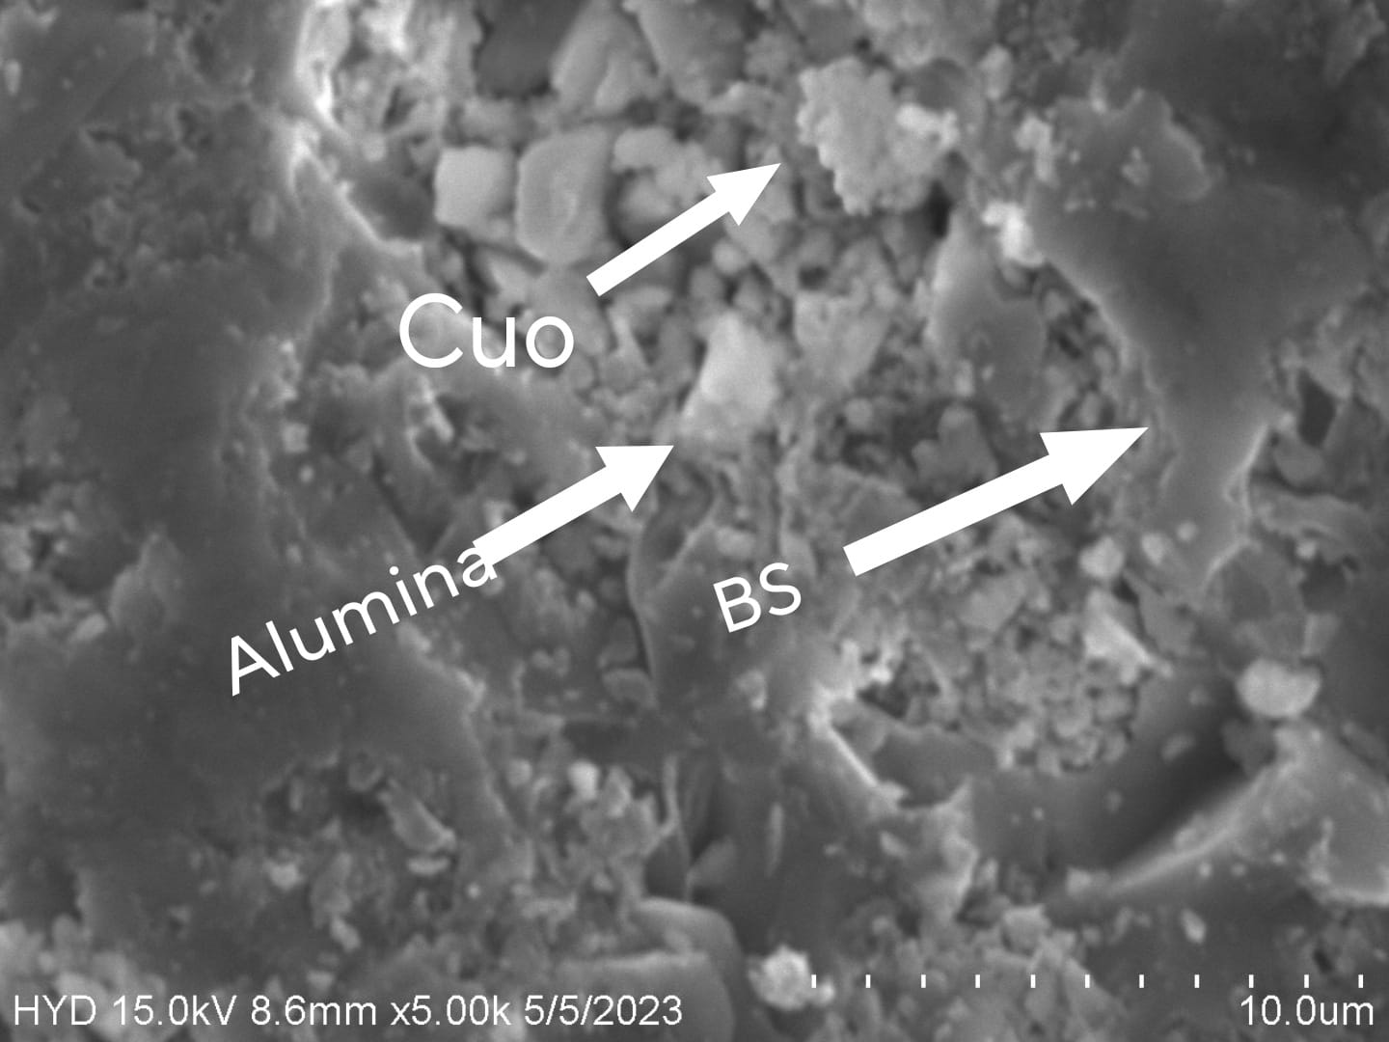

Figure 6.13: SEM image of Borosilicate(80%) +Alumina(10%)+ Copper oxide(10%)

from the Figure 6.10 we could easily see the smooth formation of the glass in the image. this Figure 6.10 is 100% borosilicate and consists of complete glass molecules

Next Fig 6.11 is the sample is the mixture of borosilicate of 80 wt% and alumina 20 wt%, it is showing the traces of glass shards as the long smooth structures as the aluminium provided the extra heat and even glass and the small enclosed molecules are the alumina which provide the rigidity to the composite

Here in Figure 6.12 SEM Analysis of the composites shows us the formation of the glass for the borosilicate, the glass formed around 20um diameter rods likes structure and small diminishing particles are nanoparticles of copper oxide

The next fig 6.13 is the whole composite consisting all three materials as borosilicate 80 wt%, alumina 10wt% and copper oxide 10wt%, these composite displays the structure of all three materials with its collective strengths. the long shards are the glass (borosilicate) which is clearly most of the composite and the very tiny spheres collectively stacked are the copper oxide and the blocks of little shiny texture and visibility are the alumina

# CHAPTER- 7

# 7.1 Conclusions:

The addition of the Alumina (Al2O3) and Copper Oxide (Cu2O) components to the existing Borosilicate composite has resulted in the improvement in the structure, micro structure, and mechanical hardness. This improvement has been achieved by the study and experimentation of various compositions of the materials selected. The sintering process utilized for the preparation of the composite material pellets has resulted in grain growth of the materials and this makes the pellets more dense and stronger and appropriate for testing. The Structural analysis by an Optical Microscope showed the absence of any defects on the surface of the composite material. The Microstructural analysis by SEM analysis showed the formation of glass of Borosilicate, chip formation by Alumina (Al2O3) and sphere formation by Copper Oxide (Cu2O). And from all the above information and observations, we can infer that the addition of 10% Alumina (Al2O3) to 90% Borosilicate has given the highest hardness values which is performed by Micro Vickers Hardness test and the next highest hardness is seen in the composite comprising all the 3 materials. We can also observe trends in the composite material hardness where the addition of Alumina (Al2O3) initially increases the hardness but further addition reduces it, as compared to 100% Borosilicate and the addition of Copper Oxide (Cu2O) increases the hardness as the wt% is increased. This shows that the expected outcomes have been achieved and the required properties have improved with respect to the original 100% Borosilicate composition.

# 7.2 Future Scope:

The research done till this point through this project proves that a slight addition of Alumina and Copper Oxide to the borosilicate composite can improve its properties by a substantial value and shows a better microstructure of the pellets. While this project has achieved its main objective of improving the said properties of Borosilicate, there are several areas where the project can be extended and improved. New materials and more cost-efficient materials may be used for the composite preparation. More compositions and more precise compositions can be tried for the same materials. The sintering process can be replaced by glass preparation process to achieve better

# CHAPTER 8

# REFERENCES

[1] D. Ramakanth, S. Singh, P. K. Maji, Y. S. Lee, and K. K. Gaikwad, “Advanced packaging for distribution and storage of COVID-19 vaccines: a review,” *Environ. Chem. Lett.*, vol. 19, no. 5, pp. 3597–3608, 2021, doi: 10.1007/s10311-021-01256-1.

[2] B. Mos, C. Holloway, B. P. Kelaher, I. R. Santos, and S. A. Dworjanyn, “Alkalinity of diverse water samples can be altered by mercury preservation and borosilicate vial storage,” *Sci. Rep.*, vol. 11, no. 1, pp. 1–11, 2021, doi: 10.1038/s41598-021-89110-w.

[3] N. H. Shamsudin, K. A. Abdul Khalid, and K. Mohamed, “Synthesizing vertically aligned zinc oxide nanowires on borosilicate glass using vapor trapping approach,” *Adv. Mater. Res.*, vol. 1024, pp. 87–90, 2014, doi: 10.4028/www.scientific.net/AMR.1024.87.

[4] R. A. Schaut and W. P. Weeks, “Historical review of glasses used for parenteral packaging,” *PDA J. Pharm. Sci. Technol.*, vol. 71, no. 4, pp. 279–296, 2017, doi: 10.5731/pdajpst.2016.007377.

[5] A. Wereszczak, K. Johanns, C. J. Anderson, T. Behner, and P. Patel, “Strength and contact damage responses in a soda-lime-silicate and a borosilicate glass,” no. OCTOBER 2006, 2006, [Online]. Available: http://oai.dtic.mil/oai/oai?verb=getRecord&metadataPrefix=html&identifier=ADA481685

[6] P. Aly, A. A. El-Kheshen, H. Abou-Gabal, and S. Agamy, “Structural investigation and measurement of the shielding effect of borosilicate glass containing PbO, SrO, and BaO against gamma irradiation,” *J. Phys. Chem. Solids*, vol. 145, no. April, p. 109521, 2020, doi: 10.1016/j.jpcs.2020.109521.

[7] D. Ditter *et al.*, “Impact of Vial Washing and Depyrogenation on Surface Properties and Delamination Risk of Glass Vials,” *Pharm. Res.*, vol. 35, no. 7, 2018, doi: 10.1007/s11095-018-2421-6.

[8] S. Bruns *et al.*, “Influence of Al2O3 Addition on Structure and Mechanical Properties of Borosilicate Glasses,” *Front. Mater.*, vol. 7, p. 189, Jul. 2020, doi: 10.3389/FMATS.2020.00189/BIBTEX.

[9] R. C. C. Monteiro and M. M. R. A. Lima, “Effect of compaction on the sintering of borosilicate glass/alumina composites,” *J. Eur. Ceram. Soc.*, vol. 23, no. 11, pp. 1813–1818, 2003, doi: 10.1016/S0955-2219(02)00422-3.

[10] H. Bradtmüller, T. Uesbeck, H. Eckert, T. Murata, S. Nakane, and H. Yamazaki, “Structural Origins of Crack Resistance on Magnesium Aluminoborosilicate Glasses Studied by Solid-State NMR,” *J. Phys. Chem. C*, vol. 123, no. 24, pp. 14941–14954, 2019, doi: 10.1021/acs.jpcc.9b03600.

[11] K. Januchta, T. To, M. S. Bødker, T. Rouxel, and M. M. Smedskjaer, “Elasticity, hardness, and fracture toughness of sodium aluminoborosilicate glasses,” *J. Am. Ceram. Soc.*, vol. 102, no. 8, pp. 4520–4537, 2019, doi: 10.1111/jace.16304.

[12] R. K. Chinnam, A. R. Boccaccini, E. Bernardo, and H. Epstein, “Glass-ceramic composites from borosilicate glass and alumina-rich residues,” *Int. J. Appl. Ceram. Technol.*, vol. 12, no. S2, pp. E19–E27, 2015, doi: 10.1111/ijac.12197.

[13] M. M. R. A. Lima, R. C. C. Monteiro, M. P. F. Graça, and M. G. Ferreira Da Silva, “Structural, electrical and thermal properties of borosilicate glass-alumina composites,” *J. Alloys Compd.*, vol. 538, pp. 66–72, 2012, doi: 10.1016/j.jallcom.2012.05.024.

[14] Y. Paulıukevıch *et al.*, “Effect of aluminum-containing raw materials on the melting of borosilicate glass for fiber,” *Ceram. Int.*, vol. 47, no. 22, pp. 31092–31098, 2021, doi: 10.1016/j.ceramint.2021.07.283.

[15] A. Krishnamurthy, V. K. Michaelis, and S. Kroeker, “Network Formation in Borosilicate Glasses with Aluminum or Gallium: Implications for Nepheline Crystallization,” *J. Phys. Chem. C*, vol. 125, no. 16, pp. 8815–8824, 2021, doi: 10.1021/acs.jpcc.1c01262.

[16] A. Saini, A. Khanna, V. K. Michaelis, S. Kroeker, F. González, and D. Hernández, “Structure-property correlations in lead borate and borosilicate glasses doped with aluminum oxide,” *J. Non. Cryst. Solids*, vol. 355, no. 45–47, pp. 2323–2332, 2009, doi: 10.1016/j.jnoncrysol.2009.08.006.

[17] A. P. Raut and V. K. Deshpande, *Influence of alumina addition and gamma irradiation on the lithium borosilicate glasses*, vol. 149. Elsevier Ltd, 2018. doi: 10.1016/j.radphyschem.2018.04.011.

[18] K. P. Kumar, V. C. S. Prasad, P. S. Mukherjee, and P. G. Mukunda, “Behaviour of lead borosilicate glass/alumina composite in the temperature range 900-1100°C,” *Mater. Sci. Eng. B*, vol. 5, no. 1, pp. 1–4, 1989, doi: 10.1016/0921-5107(89)90297-3.

[19] R. T. Coyle and A. F. Shoemaker, “AI203,” vol. 39, pp. 233–238, 1980.

[20] A. A. El-Kheshen, M. F. Zawrah, and M. Awaad, “Densification, phase composition, and properties of borosilicate glass composites containing nano-alumina and titania,” *J. Mater. Sci. Mater. Electron.*, vol. 20, no. 7, pp. 637–643, 2009, doi: 10.1007/s10854-008-9778-y.

[21] G. H. Chen and X. Y. Liu, “Low-temperature-sintering and characterization of glass-ceramic composites,” *J. Mater. Sci. Mater. Electron.*, vol. 17, no. 11, pp. 877–882, 2006, doi: 10.1007/s10854-006-0039-7.

[22] M. F. Zawrah and E. M. A. Hamzawy, “Effect of cristobalite formation on sinterability, microstructure and properties of glass/ceramic composites,” *Ceram. Int.*, vol. 28, no. 2, pp. 123–130, 2002, doi: 10.1016/S0272-8842(01)00067-0.

[23] D. ŞEN BAYKAL, H. TEKİN, and R. B. ÇAKIRLI MUTLU, “An Investigation on Radiation Shielding Properties of Borosilicate Glass Systems,” *Int. J. Comput. Exp. Sci. Eng.*, vol. 7, no. 2, pp. 99–108, 2021, doi: 10.22399/ijcesen.960151.

[24] L. Perrière and Y. Champion, “Phases distribution dependent strength in metallic glass-aluminium composites prepared by spark plasma sintering,” *Mater. Sci. Eng. A*, vol. 548, pp. 112–117, 2012, doi: 10.1016/j.msea.2012.03.100.

[25] G. Banuprakash, V. Katyal, V. S. R. Murthy, and G. S. Murty, “Mechanical behaviour of borosilicate glass-copper composites,” *Compos. Part A Appl. Sci. Manuf.*, vol. 28, no. 9–10, pp. 861–867, 1997, doi: 10.1016/S1359-835X(97)00052-3.

[26] B. Li, Y. Xu, and S. Zhang, “The size-effect of Al2O3 on the sinterability, microstructure and properties of glass-alumina composites,” *Glas. Phys. Chem.*, vol. 41, no. 5, pp. 503–508, 2015, doi: 10.1134/S1087659615050041.

[27] M. Chen, M. Shen, S. Zhu, F. Wang, and Y. Niu, “Glass-alumina composite coatings for high temperature corrosion protection. Part I: Effect of crystallization and interfacial reaction on the thermo-physical properties,” *Mater. Sci. Eng. A*, vol. 528, no. 7–8, pp. 3186–3192, 2011, doi: 10.1016/j.msea.2010.12.090.

[28] W. D. Wolf, K. J. Vaidya, and L. F. Francis, “Mechanical properties and failure analysis of alumina-glass dental composites,” *Journal of the American Ceramic Society*, vol. 79, no. 7. pp. 1769–1776, 1996. doi: 10.1111/j.1151-2916.1996.tb07994.x.

[29] B. H. Bae, J. W. Lee, J. M. Cha, I. W. Kim, H. Do Jung, and C. B. Yoon, “Preliminary characterization of glass/alumina composite using laser powder bed fusion (L-PBF) additive manufacturing,” *Materials (Basel).*, vol. 13, no. 9, 2020, doi: 10.3390/ma13092156.

**SHOW AND TELL**

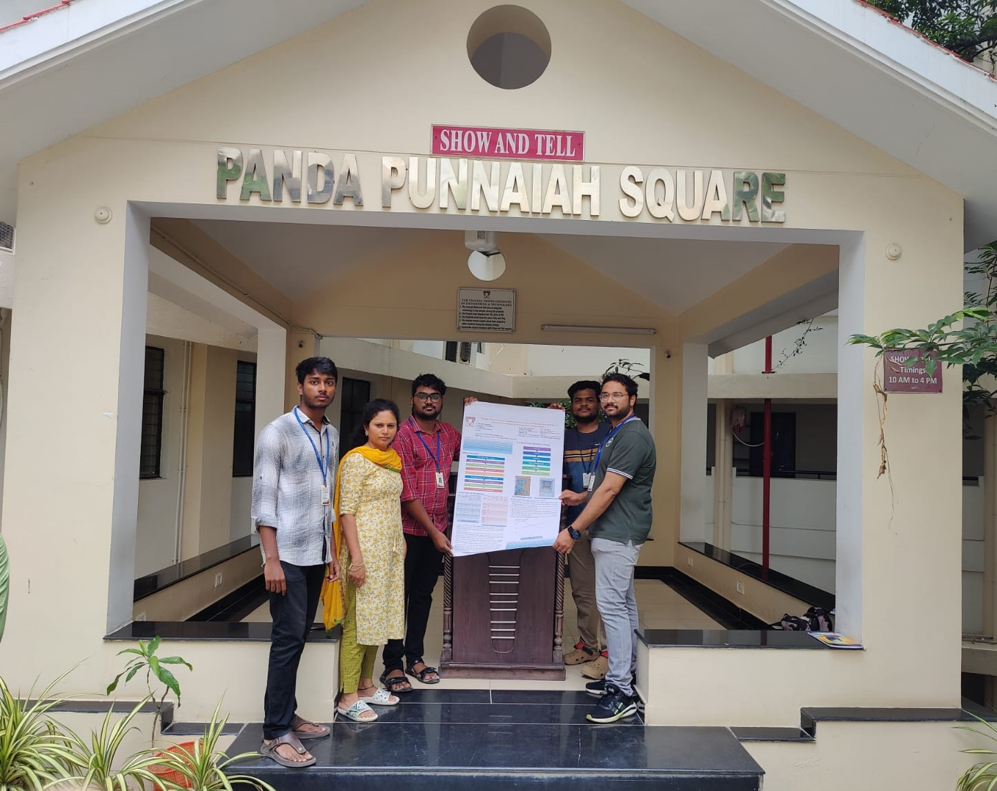

PEOPLE FROM LEFT TO RIGHT

M. SUJITH CHANDRA

DR. CH. PRIYADARSINI

PATHIPAKA SIDDARDTH

P.V.S SURAJ

V. SIMON PRASHANTH